**Nomura America Services**

**Document Metadata Management**

**Functional Specifications Document**

*Version 1.6*

Nomura Research Institute America, Inc.  
810 Seventh Avenue, 25th Floor, New York, NY 10019, U.S.A.  
<http://fis.nri.co.jp/en/index.html>

**Document Version Control**

| **Version** | **Prepared By** | **Comments** | **Date** |
| --- | --- | --- | --- |
| 0.1 | Rajesh / Boopala Saravanan | Draft Preparation | Apr 17, 2016 |
| 0.2 | Rajesh / Boopala Saravanan | Additional scenarios added in sections 4.1, 4.2 and 4.3.  DMM Message Reader logic included.  ERD in Section 7.1 updated | Apr 20, 2016 |
| 0.3 | Rajesh / Boopala Saravanan | Client Onboarding terminology renamed to Account/Counterparty onboarding.  ACE to DMM communication changed from Queue to File and from Real time to EOD. | Apr 21, 2016 |
| 0.4 | Rajesh / Boopala Saravanan | Section 3 updated to include Rule execution Batch and Association Authorization.  Section 4.1.2 updated to include Account to Account and CCP to CCP documents association.  Section 4.1.3 introduced to authorize association.  Section 4.4.7 included for Rule Execution batch.  Data conditions for scenario 4.4.1 and 4.4.4 updated.  ERD in Section 7 updated to include Account to Account and CCP to CCP documents association.  Section 9.4, 9.6, 9.8 modified to include the layout.  Section 9.7 included to specify DMM to RDM file layout. | Apr 28, 2016 |
| 1.0 | Rajesh / Boopala Saravanan | Section 2 System overview diagram updated.  Section 3.1, 3.5 updated based on NEAM flow change.  Section 4.3.1 updated based on NEAM and RDM flow changes.  Section 4.4.5.2 updated and section 4.4.5.3 added for TAKARA.  Section 4.4.7 included for Rule Execution batch.  Section 6.1 updated based on NEAM flow change and added additional interface for TAKARA.  Section 7 updated with latest ERD.  Section 9.3 updated based on NEAM flow change.  Sample message updated for Section 9.4, 9.6 and 9.8 | May 10, 2016 |
| 1.1 | Rajesh / Boopala Saravanan | Section 4.1.2 updated to include Extension date and upload override logic, approval for upload override, association added.  Section 4.1.3 updated to inherit docs from CCP to Account once the association is approved.  Section 4.3.1.1 and 4.3.1.2 updated with rule execution logic  Section 4.4.5 updated with violation identification logic.  Section 4.1.4 updated to include upload override and extension date logic.  Section 3 updated to remove audit trail functionality and Section 4.1.1 updated to include audit popup functionality. | May 25, 2016 |
| 1.2 | Rajesh / Boopala Saravanan | Based on the review comments from Tom, Jeanine, Soheil, Ryan and Manash.  **Change Points:**  Section 1.1 and Section 1.2 updated with NTAPS as current account master and RDM as future account master.  Current system overview diagram in Section 1.2 updated  Dashboard and ACE to DMM outlines in Section 2 updated.  Section 3.1 updated to include scenario if onboarding happens directly to RDM.  Section 3.4 updated to include documents from DL and loaded via DMM for trade reconciliation.  Section 4.1.2 updated to include Account status check, non-editable RDM fields, upload override, association to Account from CCP, LCP and Accounts and document purpose scenarios.  Section 4.1.3 updated include scenarios of upload override, extension and document purpose scenarios.  Section 4.1.4 updated to include Account status in scenarios and added Extension ending documents queue.  Section 4.3.1.1 updated to include account status check for rule execution and also added entity type rule execution.  Section 4.3.1.2 updated to include entity type rule execution.  Section 4.4.2, 4.4.3, 4.4.5.1, 4.4.5.3 and 4.4.6 updated to change input format from CSV to Pipe ‘|’ delimited dat file.  A-12 added as an assumption in Section 4.5.  Section 6.1 updated to change format from CSV to Pipe ‘|’ delimited dat file.  Section 7.1 updated with latest ERD.  Section 7.2 updated to increase data retention from 9 to 10 years.  Section 9.3 updated for NEAM message attributes. | June 08, 2016 |
| 1.3 | Rajesh / Boopala Saravanan | Section 4.3.1.1 and section 4.3.1.2 updated with rule re-execution scenario when an Account changes from INACTIVE/CLOSED -> ACTIVE.  ERD updated in section 7.1 | June 17, 2016 |
| 1.4 | Boopala Saravanan | Section 4.3.1.1 and section 4.3.1.2 updated with rule re-execution scenario when an Account changes from INACTIVE/CLOSED -> ACTIVE based on Jeanine’s comment. | June 29, 2016 |
| 1.5 | Boopala Saravanan | Please refer the FSD_Updates.xlsx for the changes. | August 26, 2016 |
| 1.6 | Boopala Saravanan | Changes related to addition of new Documents for Approval queue is made in the following sections.  Section 2  Section 3  Section 4.1.4  Changes related to addition of new screen User Reopen is made in the following sections  Section 2  Section 3  Section 4.2.3  Sample screens replaced in Section 4.  SSO logic updated in Section 5.7  Software configurations updated in Section 8.5  File layout updated in Sections 9.3, 9.5 and 9.7.1  Expiry Date logic updated in Section 4.1.2  Document Purge functionality removed from Section 2  Message format for RDM updated in Section 6.1  Expression for date fields in query screen added in Section 4.1.1 | December 22, 2016 |

**Reference Documents**

| **Document** | **Version** | **Prepared By** | **Date** |
| --- | --- | --- | --- |
| **Document Management Strategy**  Phase 1: Document Tracking & ACE/NEAM Integration  - Business Requirements Document | 1.0 | Ryan Crenshaw | May 24, 2016 |
| US MLQs | 15 |  |  |
| Doc Mapping and Requirements |  | Ryan Crenshaw |  |
| DMM Diagrams_20160509_Approved.pdf | 1.6 | Soheil Arian | May 09, 2016 |
| doc mapping 5-26-16.xlsx |  | Jeanine/Ryan | May 27, 2016 |
| Copy of NRI rules logic 5-26-16.xlsx |  | Jeanine/Ryan | May 27, 2016 |

**Document Approval**

| **Name** | **Function / Department / Organization** | **Level** | **Sign-off Date** | **Version** |
| --- | --- | --- | --- | --- |
| Thomas Sawyer | Head of Regulatory Operations / NAS | VP |  |  |
| Jeanine Liguori | KYC CAA / NAS | VP |  |  |
| Dontae Slaughter | Account/Counterparty Onboarding / NAS | VP |  |  |
| Manash Banerjee | [Global Head of Entity Reference Data Technology](https://www.linkedin.com/title/executive-director,-global-head-of-entity-reference-data-technology?trk=pprofile_title) / NAS | Global Head |  |  |

**Document Distribution**

| **Name** | **Function / Department** | **Level** | **Organization** |
| --- | --- | --- | --- |
| Thomas Sawyer | Head of Regulatory Operations | VP | NAS |
| Jeanine Liguori | KYC CAA | VP | NAS |
| Dontae Slaughter | Account/Counterparty Onboarding | VP | NAS |
| Manash Banerjee | [Entity Reference Data Technology](https://www.linkedin.com/title/executive-director,-global-head-of-entity-reference-data-technology?trk=pprofile_title) | Global Head | NAS |
| Ryan Crenshaw | Change Management Team | BA/PM | NAS |
| Soheil Arian | Reference Data IT | Head | NAS |
| Kazumitsu Yokokawa | Financial Services Technology Group | Director | NRIA |
| Hirokazu Horii | Financial Services Technology Group | PM | NRIA |
| Sofiya Kantorovich | Financial Services Technology Group | BA | NRIA |

**TABLE OF CONTENTS**

1 Introduction 9

1.1 Background 9

1.2 Current Process 9

1.3 Pain Points of the current process 11

1.4 Objectives of the Proposed Solution 11

2 System overview diagram 12

3 Business flow use cases 15

3.1 Account/Counterparty Onboarding 15

3.2 Account/Counterparty Information Updates 16

3.3 Document Trade Reconciliation 16

3.4 TAKARA Integration 18

3.5 Document Management 18

3.6 User and Role Management 19

3.7 Rule Management 19

3.8 Document Expiration Batch 20

3.9 DMM to RDM Restriction file generation batch 20

3.10 Rule Execution 21

3.11 Dashboard 21

4 Detailed Functional List 22

4.1 Online processing 22

4.1.1 Search (counterparty/ account/document/document type/service/product/trade type) 22

4.1.2 Metadata maintenance (add / amend / delete) 27

4.1.3 Authorization 35

4.1.4 Dashboard 36

4.2 Administration online processing 40

4.2.1 Rule maintenance (add / amend / delete) 40

4.2.2 User group maintenance 47

4.2.3 User maintenance 57

4.3 Services and background processes 66

4.3.1 RDM & NEAM messages load 66

4.3.2 Takara Message Creation 70

4.4 Batch processing 71

4.4.1 Document Expiration 71

4.4.2 Data Legal Update 71

4.4.3 Trade File Loading 72

4.4.4 Trade Exception Status Update 73

4.4.5 Downstream loads 74

4.4.6 Rule Execution Batch 75

4.5 Assumptions (Applicable for Phase 1) 76

4.6 Dependencies 76

5 Non-functional requirements 77

5.1 UI Performance & Language support 77

5.2 Capacity 77

5.3 Business Continuity 77

5.4 Service / Operational level 77

5.5 Archiving 78

5.6 System operation Tool 78

5.7 Single sign on 78

5.8 NSI Style sheets 78

6 System interface requirement 84

6.1 System interface specifications (Source system, protocol, format (xml/csv), frequency / timing) 84

7 Database design 85

7.1 ER-D 85

7.2 Data retention 90

8 Deployment requirements 91

8.1 Data security 91

8.2 Disaster recovery 91

8.3 Build tools 91

8.4 Day zero load 91

8.5 Software / Hardware requirement 92

9 Appendix 94

9.1 Documentum API 94

9.2 RDM XML Message 94

9.2.1 Organization message 94

9.2.2 Account open message 95

9.2.3 Account close message 95

9.3 NEAM Request Attributes 96

9.3.1 ACCOUNT Array: 96

9.3.2 ORGANISATION Array: 96

9.4 TAKARA XML Message 96

9.5 Data Legal DAT File 97

9.6 DMM to RDM Account Status file 98

9.7 Operations file 98

9.7.1 Trade File from NCDI 98

9.8 Glossary 99

# Introduction

This document captures the functional and the non-functional requirements for a centralized document tracking Web Application system called the Document Metadata Manager (DMM).

This document considers the DMM Business Requirements document as the input and

* expands each of the Business Requirement into its corresponding functional requirements in the form of business flow, screen images and functional scenarios
* Describes the overall system architecture showing the different interfaces to the various external systems.
* Shows the conceptual data model in the form of an ERD

On the other hand, this document does not deal with the detailed design of the system which would be explained in a separate design document.

## Background

Nomura America Services, LLC., Inc. (hereafter, NAS) currently provides the document control service for the US region through NTAPS. NTAPS allows to monitor regulatory requirements specific to KYC, AML, and specific legal items and stay in compliance with regulations on account and counterparty (DESI) levels.

It has been decided to decommission NTAPS and create a Global platform to manage all document requirements and be compliant with regulations regarding Account/Counterparty Onboarding and KYC for all regions.

Document Metadata Manager (DMM) is a platform to provide necessary document control functionality integrating future Account Master (RDM), Account/Counterparty Onboarding (NEAM) system, KYC application and Document storage (Documentum) platform.

First phase of the implementation is tightly coupled with the NTAPS decommissioning process and covers the US region only.

## Current Process

Current process utilizes NTAPS functionality for document control, NEAM for Account/Counterparty Onboarding, NTAPS for Account Master, Documentum for document storage and requires multiple entry points, manual actions, and paper trail.

NTAPS functionality helps identify necessary documents based on account classification with limited help in changing requirements and applications integration.

Risk is mitigated by strict user review based on over a 100 reports with limited help from the automated solutions. It is possible to be in violation on multiple points, such as, missing or expired documents, inadequate data access control and no document retention rules etc.

**Current Method of Document Tracking within NTAPS**



## Pain Points of the current process

Pain points of the current process of managing the document tracking include but are not limited to

* dual entry of account/document information
* necessity to store paper trail to comply with KYC and other requirements
* manual review of reports
* manual annotation of the reports
* additional scanning and storing
* no centralized repository for various teams
* excessive use for email communication
* exception logic is not transparent

Suggested solution will streamline the process and eliminate pain points on a multi-phase approach starting with immediate needs related to NTAPS decommissioning and ending with a truly global solution.

## Objectives of the Proposed Solution

Overall project objective is to create a global solution for securing, storing, profiling, monitoring and maintaining documents which would enhance NEAM and RDM in order to serve NTAPS downstream consumers and to ultimately remove any dependencies on NTAPS as the point of entry for reference data. The primary objectives are listed as below.

|  |  |  |  |
| --- | --- | --- | --- |
| **Ref ID** | **Objective** | **Phase** | **Benefit** |
| **1** | Define a target operating model for supporting document tracking and management in a post NTAPS environment | 1 | Document Management Strategy |
| **2** | Provide search functionality for documents | 1 | Document Management Strategy |
| **3** | Define associated triggers for managing frozen accounts | 1 | Document Tracking |
| **4** | Implement the concept of core metadata into the identified document tracking and management solution | 1 | Document Tracking |
| **5** | Creation of queues to manage the remediation of documents | 1 | Document Tracking |
| **6** | Implement a data governance model consistent with RDM | 1 | Document Tracking |
| **7** | Integrate with the US Documentum Repository defined as CustAccounts | 1 | NEAM/ACE Integration |
| **8** | Integrate DMM with NEAM for US booking entity use and provide enhanced workflow functionality | 1 | NEAM/ACE Integration |

# System overview diagram

From the Business Requirements Specifications, the following high level functional requirements have been identified.

Based on the overall objectives of the proposed DMM Business requirements and the identified functional requirements, the below system overview diagram is arrived that shows the DMM Application overview along with its external system interface and protocol details. The DMM application itself uses the FINCH framework for the UI architecture.

|  |  |  |  |
| --- | --- | --- | --- |
| **Function** | | | **Outlines** |
| Dashboard | | | Following information are shown in the dashboard.  Errors / Processed data / Reports / Expiring documents / Grace period ending documents / Missing documents / Documents for Approval / Account restricted / Trade violations/Extension ending documents |
| Metadata management | | Entry / Query / Amend screen | User can add / amend / delete document metadata through the screens. User must be able to query the meta-data available in DMM. |
| Authorize screen | Documents uploaded for document type which is configured to be approval required, documents which are extended or upload overridden and documents associated from one CCP -> CCP or from one Account -> Account can be authorized using this screen. |
| Rule Management | | Entry / Query / Amend screen | User can Entry / Query / Amend / Delete rules through the screens. |
| User Management | User | Entry / Amend / Query / Delete / Reopen screen | User can add / search / amend / delete / reopen user through the screens. |
| User Role | Entry / Amend / Query / Delete screen | User can add / search / amend / delete user role through the screens. |
| System Integration | | RDM Message Consumer | DMM receives Account and Organization message from RDM and stores in it. |
| NEAM Account/CCP/LCP registration web service | NEAM makes a web service call to DMM to register Account/CCP/LCP. |
| DMM to RDM Restriction file generation batch | DMM generates two different files, one for CCP and the other one for ACCOUNT and sends to RDM with list of CCP/Accounts that are identified to be Restricted based on the Document status. |
| Document Expiration Batch | Documents Missing/Grace Period Ended/Expired will be calculated for each documents using this batch. |
| Data Legal Update Batch | DMM consumes a file through FTP from Data Legal. Document records for LCP will be created / updated based on the file received from Data Legal. |
| Trade file Consumer Batch | DMM consumes a file through FTP from NCDI and store it in DMM side for reconciliation. |
| Trade Exception Status Update Batch | DMM consumes a file through FTP from NCDI. Trade violations by Trading Account will be identified and shown in Dashboard. |
| TAKARA Message Creation processor | XML message file with document meta-data information will be sent to Takara on a real time basis. |
| TAKARA Daily night dump file creation Batch | Pipe ‘|’ delimited dat file with all the metadata information in DMM will be created and transferred to TAKARA through FTP. |
| Documentum | Documents uploaded through Metadata management should be stored in Documentum. DMM needs to be integrated with Documentum to support Document upload/retrieve/delete operations. |
| Rule Execution | This batch executes rule and decides the list of documents required for the existing RDM data. |
| Backup Message processor | This service is used to write the successfully processed incoming RDM messages to a file in a backup location. |
| Error Message processor | This service is used to write the error RDM messages with error description to error queue. |
| ~~Document Purge~~ | ~~This process is used to purge the documents that are inactive for a long time.~~ |

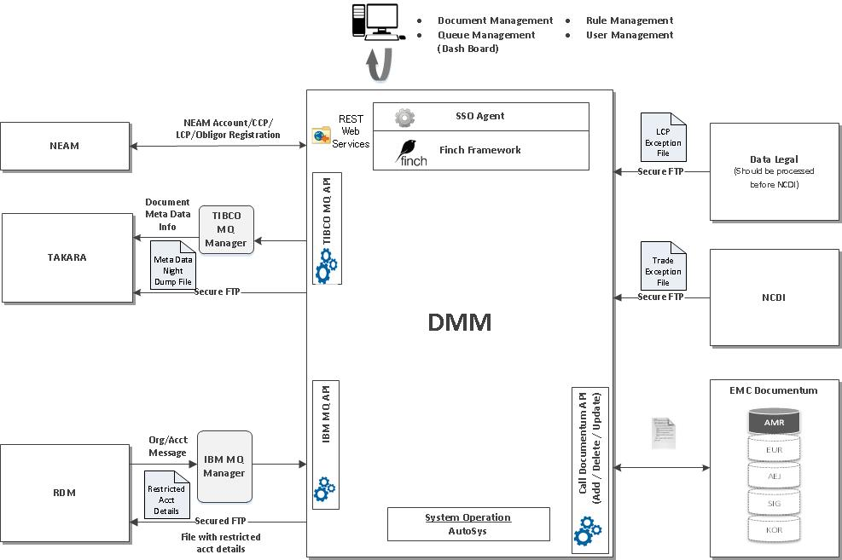

# Business flow use cases

The high level Business flow use cases showing the flow between the various systems and the DMM Application itself are shown under different functional heads that have been identified.

## Account/Counterparty Onboarding

Account/Counterparty onboarding happens in NEAM with a NEAM ID being generated as soon as the forms are submitted. As the RDM ID is not generated yet, user can request DMM to register the NEAM Account/CCP/LCP with a NEAM ID. Later when the RDM ID is generated, the DMM receives the RDM Account message which will contain the RDM ID along with the NEAM ID. DMM assigns the earlier assigned documents to the corresponding RDM ID. Onboarding directly to RDM is covered by RDM Message processing.

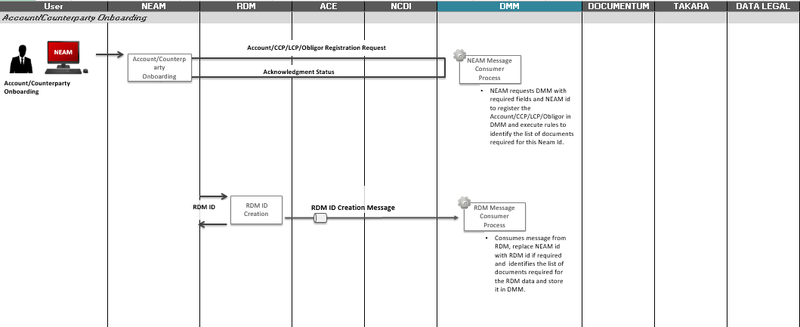

## Account/Counterparty Information Updates

If there is an update in the RDM Account/CCP or LCP, then the DMM receives an updated RDM Account/Organization message. And, if an RDM Account is closed, then the DMM receives an RDM Account close message. These information are updated in DMM.

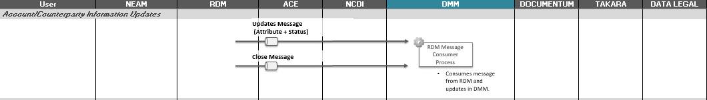

## Document Trade Reconciliation

DMM consumes a file through FTP from Data Legal and NCDI. List of documents and its status for LCP are to be updated based on the file received from Data Legal. This process is similar to RDM/NEAM process for client on-boarding with the difference of no having actual URLs. Waterfall flag is set up as ‘Y’ for LCP service/document rule. Trade exceptions are to be updated based on the file received from NCDI with trade-type and the document information received from both Data legal and documents loaded via DMM.

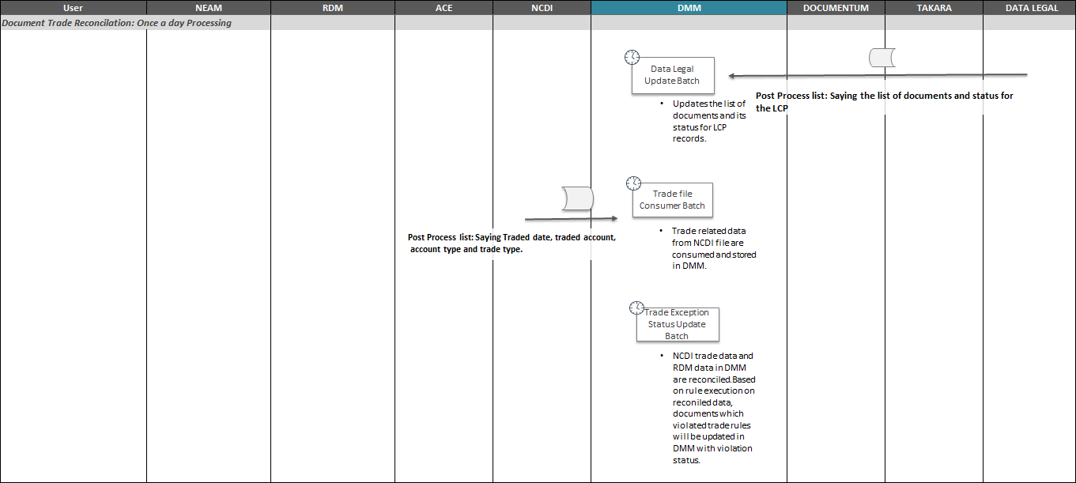

## TAKARA Integration

Document metadata should feed into Takara to enable reporting and warehousing of the document related information for the proactive trade-prevention or account opening blocks in the future state.

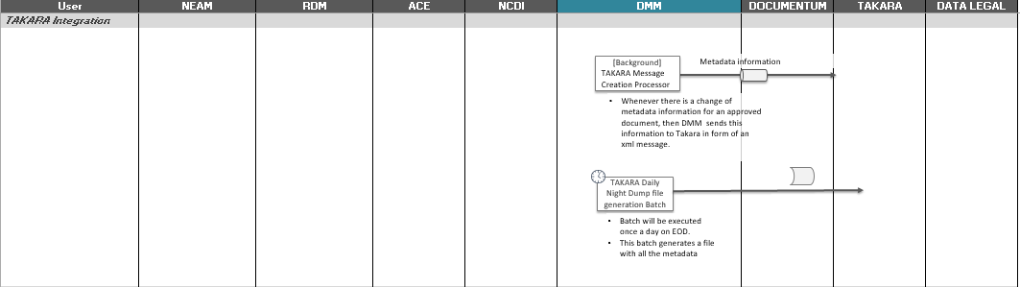

## Document Management

Document and its Metadata information for the RDM id can be managed using Document metadata management functions.

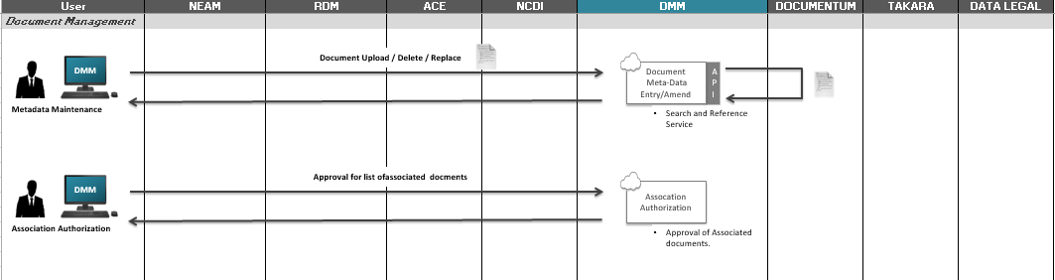

## User and Role Management

User and user role details can be managed using this function.

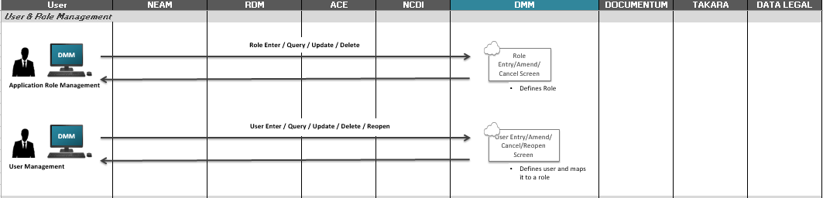

## Rule Management

Service level and Document level rules will be maintained using the Rule management screens.

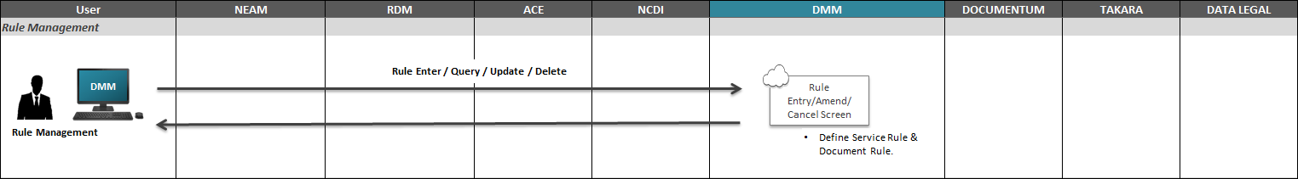

## Document Expiration Batch

Document status will be decided based on the document and service rule available in DMM.

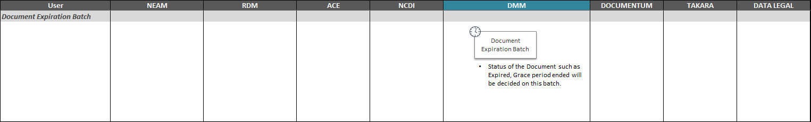

## DMM to RDM Restriction file generation batch

DMM generates two different files, one for CCP and the other one for Account with RDM id and the reason for restriction and sends the files to RDM.

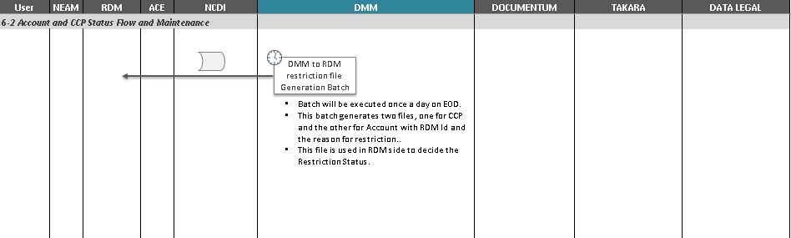

## Rule Execution

This batch will be executed to Re-execute the rule for the existing Accounts/CCP based on Service Id, Service Id with Account/CCP open date and RDM Id with hierarchical level.

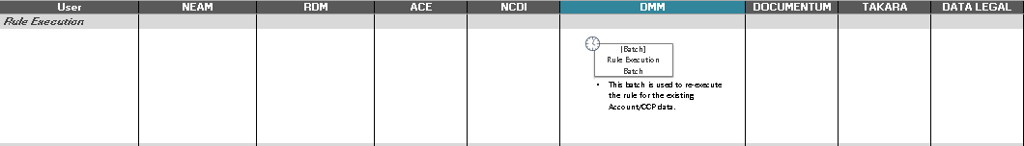

## Dashboard

On the DMM Dashboard, User can view the current status of documents such as Errors / Processed data / Reports / Expiring documents / Grace period ending documents / Missing documents / Account restricted / Documents for Approval / Trade Violations

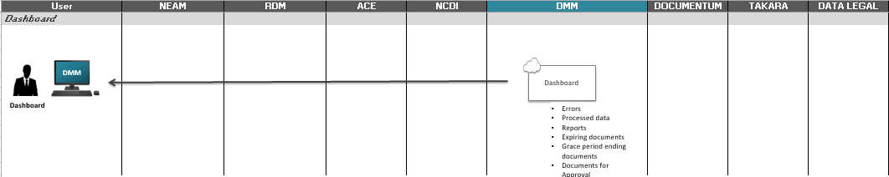

**Note:** A more complete and detailed version of the Business flow that captures the flow between the DMM and the other systems as well as the flow within the DMM Application is found in the attached document.



# Detailed Functional List

## Online processing

### Search (counterparty/ account/document/document type/service/product/trade type)

|  |  |
| --- | --- |
| **Type** | Online processing - Search |
| **Objective of the screen** | These screens are used to query the rules, audit trails and document metadata. |
| **Standard Operations available** | Query (Y/N)    Y |
| **Screen Functionality** | All the query screens supports date expressions in date fields. Some of the supported date expressions are  $today – Current Application Date  $sysDate – Current Date from DB server  $sow – Start of Week  $eow – End of Week  $som – Start of Month  $eom – End of Month  $today+?d, $today+?d – Current Application plus/minus given days.  **Rule Management Query (What If) :**   * Users can query the rules and test various scenarios of document requirements before onboarding a CCP, LCP or Account using Rule Management Query. * User can query with various criteria including Enterprise Id, Classification, Country, Product, Capacity, etc. and test the document required for the given criteria. * If the user submits without entering any query criteria, all the service rules will be displayed in the summary. * User can also choose the Rule Type like Classification Rule, Trade Type Rule, Country Rule, etc. and provide its necessary criteria to query the rules specific to this rule type. * If there are no records in DMM for the given query criteria, no results will be displayed in the summary. * User can export the result summary in Excel/PDF format. * User can select any service or document and view its details in a popup.   **Document Metadata Query:**   * User can query with various criteria including RDM Id, Hierarchy level, Document Type, Enterprise, etc. * If the user submits without entering any query criteria, all the Account/LCP/CCP will be displayed in the summary. * If there are no records in DMM for the given query criteria, no results will be displayed in the summary. * User can export the result summary in Excel/PDF format. * User can also select any Document id to view it audit history details in a popup. * User can select any RDM Id and view its meta-data details in a popup. * From the metadata detail popup, user can click on history button to view the audit history for all the documents in popup. |
| **Access Detail** | Authorized user logs into the system through Single Sign on. |

**Rule Management Query Layout:**

User can query by any criteria using fields in a query screen.

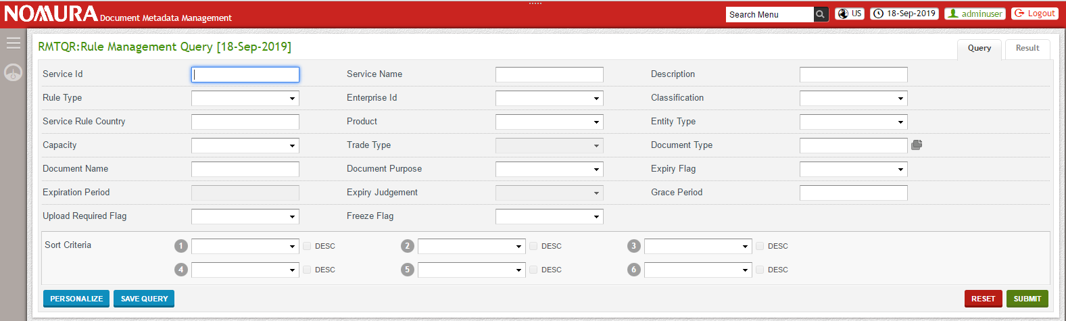

Results for the query will be listed out in query summary page based on the criteria.

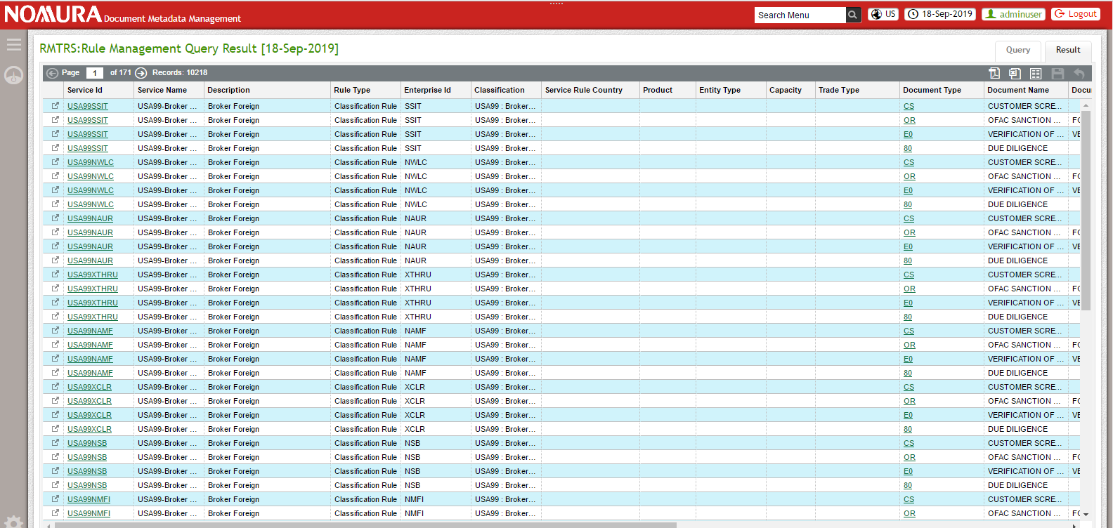

**Document Metadata Query Layout:**

User can query with any RDM Id to view its account and meta-data details.

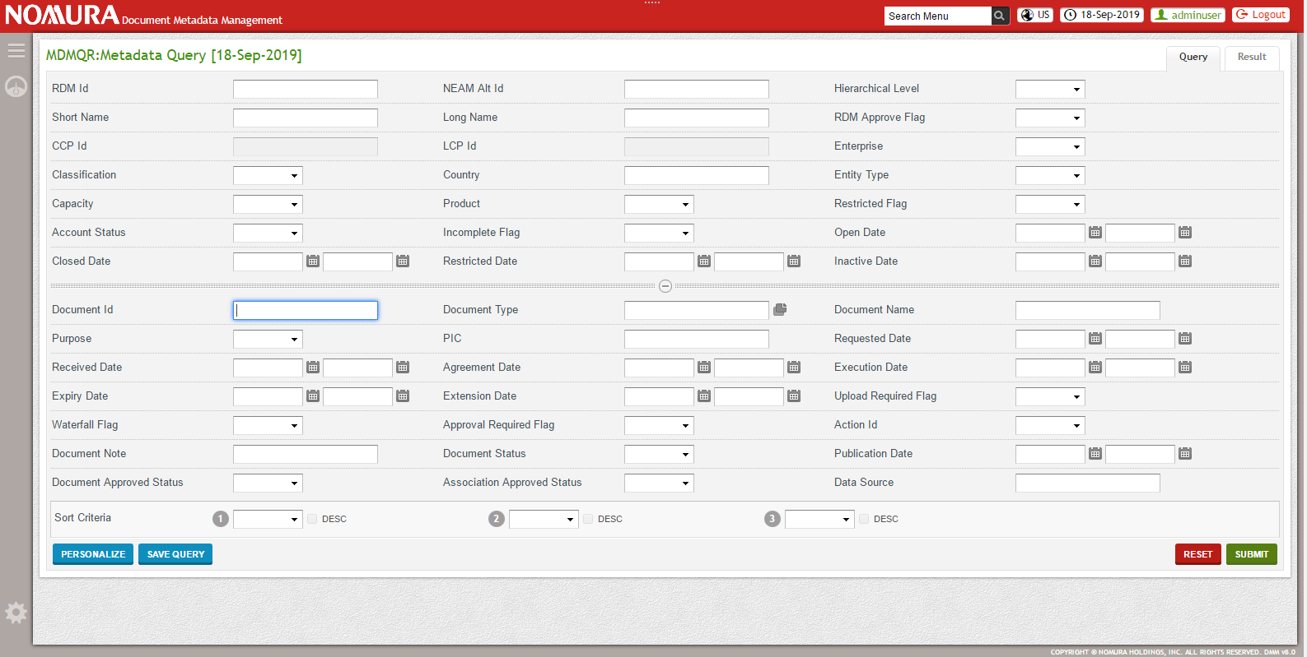

Results for the query will be listed out in query summary page based on the criteria.

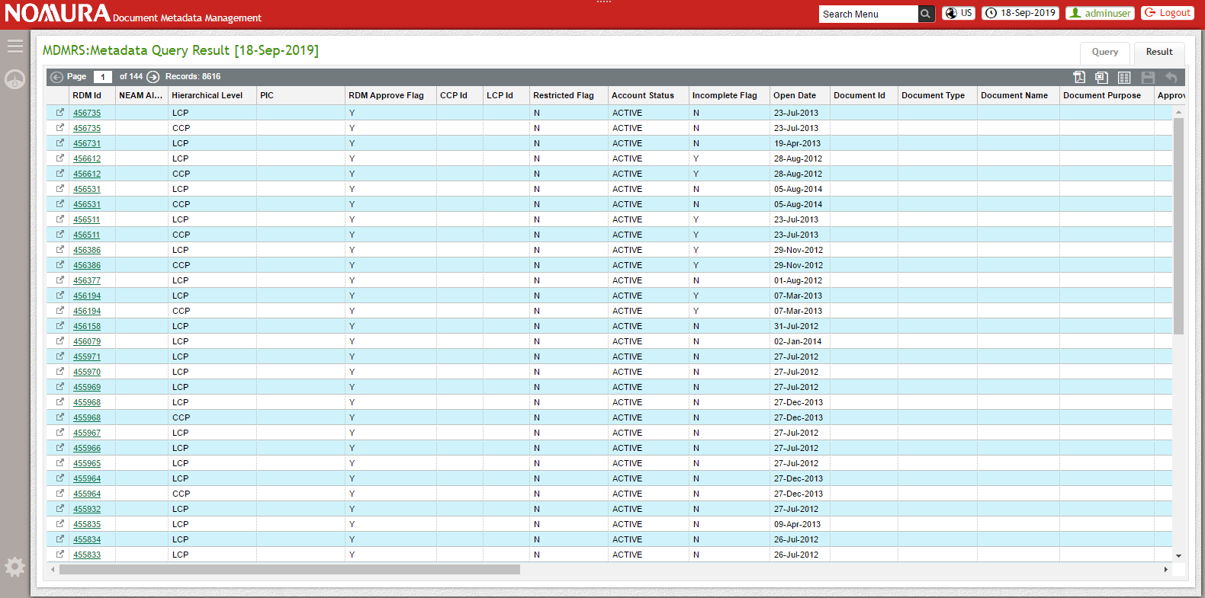

### Metadata maintenance (add / amend / delete)

|  |  |
| --- | --- |
| **Type** | Online processing - Metadata maintenance |
| **Objective of the screen** | This screen is used to enter, query and delete the metadata information. |
| **Standard Operations available** | 1. Entry (Y/N)     Y 2. Query (Y/N)    Y 3. Amend (Y/N)         Y 4. Cancel (Y/N)       Y |
| **Screen Functionality** | **Entry/Amend:**   * User can query the RDM record for which the user wants to add/amend/delete metadata information with various criteria including RDM Id, Hierarchy level, Service Id, Entity Type, Document Type, Enterprise, etc. * User can select any RDM Id which is in ACTIVE status to add, amend or remove the meta-data and its document but cannot edit the RDM loaded fields. * User cannot add, amend or remove the metadata or documents for RDM record with account status as CLOSED/INACTIVE. * User can add new document type based on service level and document level and also can delete any existing document type in this screen. * User can delete the existing document from Documentum alone and can retain its metadata. Action status of the document will be set as 'Deleted'. * User cannot delete and add the document in the documentum in a same transaction. * User cannot delete a document or document type if the document status is ACTIVE or if the document is inherited by someone. * User can override an existing document by uploading a new document. * User can provide waterfall flag only for the ACTIVE documents of CCP and LCP and not to Account. * If a metadata for a document type with waterfall flag enabled is amended in CCP/LCP, the same gets reflected to all the child Accounts with this CCP/LCP as parent. * If the waterfall flag value for a document type is “Y” then it will be inherited to all child accounts and if required can be removed from child level. If waterfall flag is “N”, then it will not be inherited to child level. * User can edit the meta-data information for the non-inherited document type and can upload the document.   + Once the user uploads the document, by default, Action status of the document will be set as 'Received'.   + Received date will be set as the current date. Agreement Date and Execution date can be entered manually by the user.   + If the Document Type is configured as ‘Expire’ in Document Rule, then Expiry Date will be calculated using Agreement Date or Execution Date and Days to Expire (Document Rule).   + If the Document Type is configured as ‘Non-Expire’ (Expiry Flag as ‘N’), then Expiry Date will be enabled for edit and the user can enter their own Expiry Date.   + Whenever there is a change in Agreement Date or Execution Date, Expiration Date will be calculated automatically based on the Agreement Date or Execution Date and Days to Expire.   + Due Date will be calculated using Requested Date and Grace period (Document Rule). * User cannot amend the auto populated values of Requested Date, Received Date, Action status, Expiry Date (when Expiry Flag is ‘Y’) and Due Date, but can amend the Agreement Date, Execution Date and Extension Date. * User can add additional purpose to the Non Active documents. Once the document is approved and moved to ACTIVE state, then user cannot amend its purpose. * If a document is uploaded for a document type, Document approved status will be decided to be in pending or Approved state based on the Approval required flag for that document type. * If a document is uploaded for a document type whose approval required flag is ‘N’, then set the document status as ACTIVE, document approve status as APPROVED, due date as empty, extension date as empty and also cancel all the existing documents for this RDM record which are not ACTIVE but with same document purpose or duplicate document type whose Action id is either OUTSTANDING or DELETED. Documents that are waiting for approval will not be cancelled. * When a document is waterfall to its Sub accounts, then it cancels all the existing documents for the sub accounts which are not ACTIVE but with same purpose as the waterfall document or duplicate document type whose Action id is either OUTSTANDING or DELETED. Documents that are waiting for approval will not be cancelled. * User can check the Upload Override and give some Document Note. Also user can upload a supporting document for upload override. This document upload will not trigger any metadata change including received date, expiry date, due date and document status. It will change the Action status to UPLOAD_OVERRIDE and sets the document approved status in PENDING state. * If user enters the Extension Date, it will change the Actions status to EXTENDED and sets the document approved status in PENDING state. * Documents in PENDING state needs to be approved by an approver. * User can associate the documents to a CCP from CCP or to Account from Account/CCP/LCP.   + Document upload or amendment of metadata information for associated documents will not be possible for the user at child level.   + Associated approved status of the associated documents will be decided to be in Pending or Approved state based on the Approval required flag for that document type.   + Associated documents of CCP that are in Pending state will not be inherited by any Accounts. Association needs to be approved by an approver. Once the Association is approved, it automatically inherits the documents to inherited Accounts.   + If the associated document is in approved state, then it cancels all the existing documents which are not ACTIVE but with same purpose as the associated document or duplicate document type whose Action id is either OUTSTANDING or DELETED. Documents that are waiting for approval will not be cancelled. * Once the document is uploaded into Documentum, user will receive the URL of the specific repository path. * Data source for the uploaded Document will be set as DMM.   **Query:**   * User can query the RDM record for which the user wants to add/amend/delete metadata information with various criteria including RDM Id, Hierarchy level, Service Id, Entity Type, Document Type, Enterprise, etc. * User can easily identify the verified documents by the KYC user from the KYC Flag of query criteria. * User can choose the Hierarchy level as ACCOUNT/CCP/LCP based on which the user can query RDM record specific to it. * If there are no records in DMM for the given query criteria, no results will be displayed in the summary. * If the user submits without entering any query criteria, all the RDM record details will be displayed in the summary. * User can export the result summary in Excel/PDF format. |
| **Access Detail** | Authorized user logs into the system through Single Sign on. |

**Metadata Entry/Amend Layout:**

User can add new document type based on service level and document level for any RDM Id (LCP, CCP or Account).

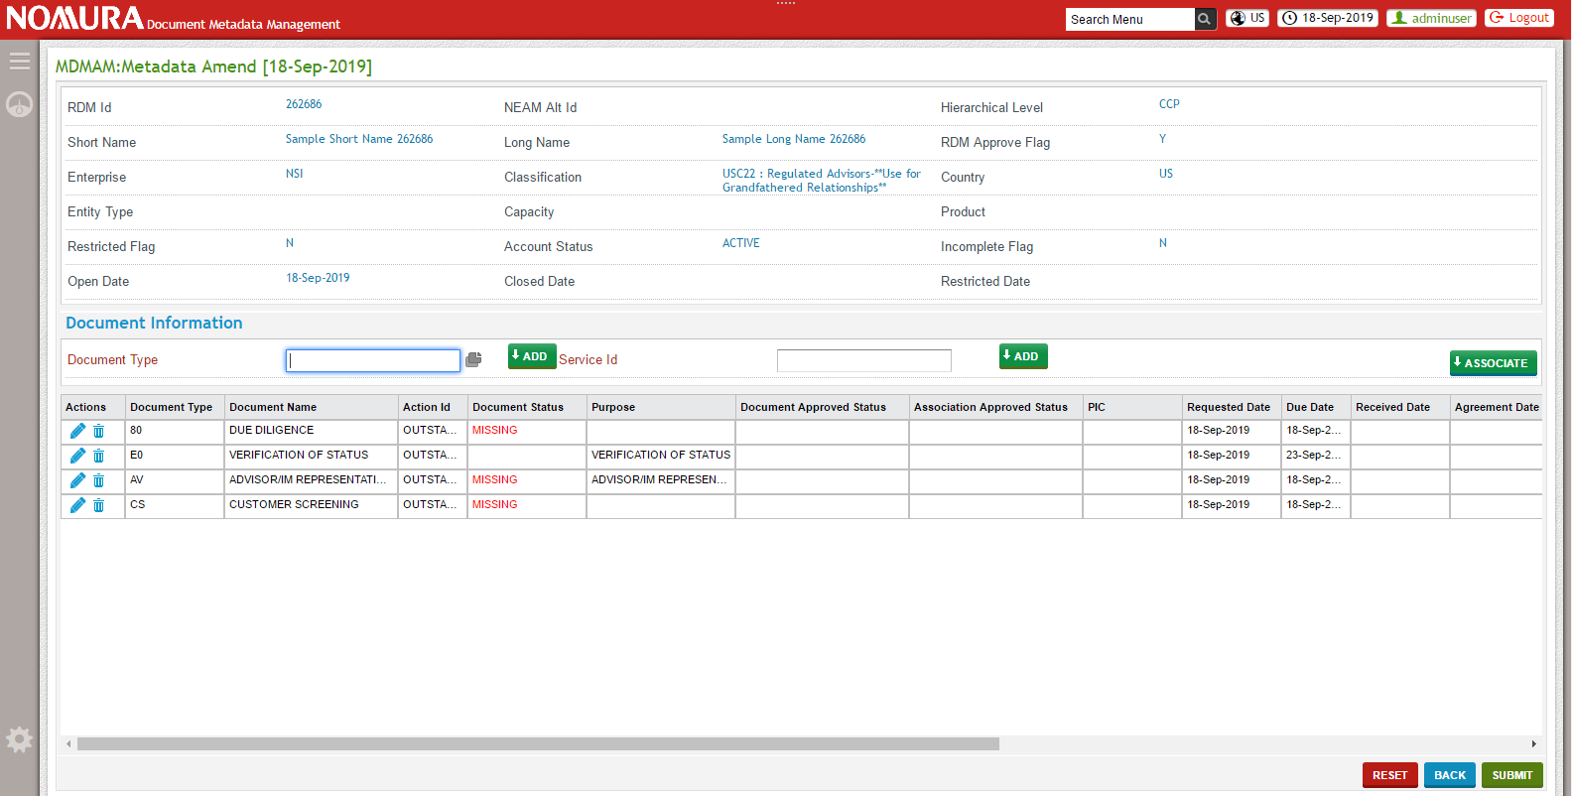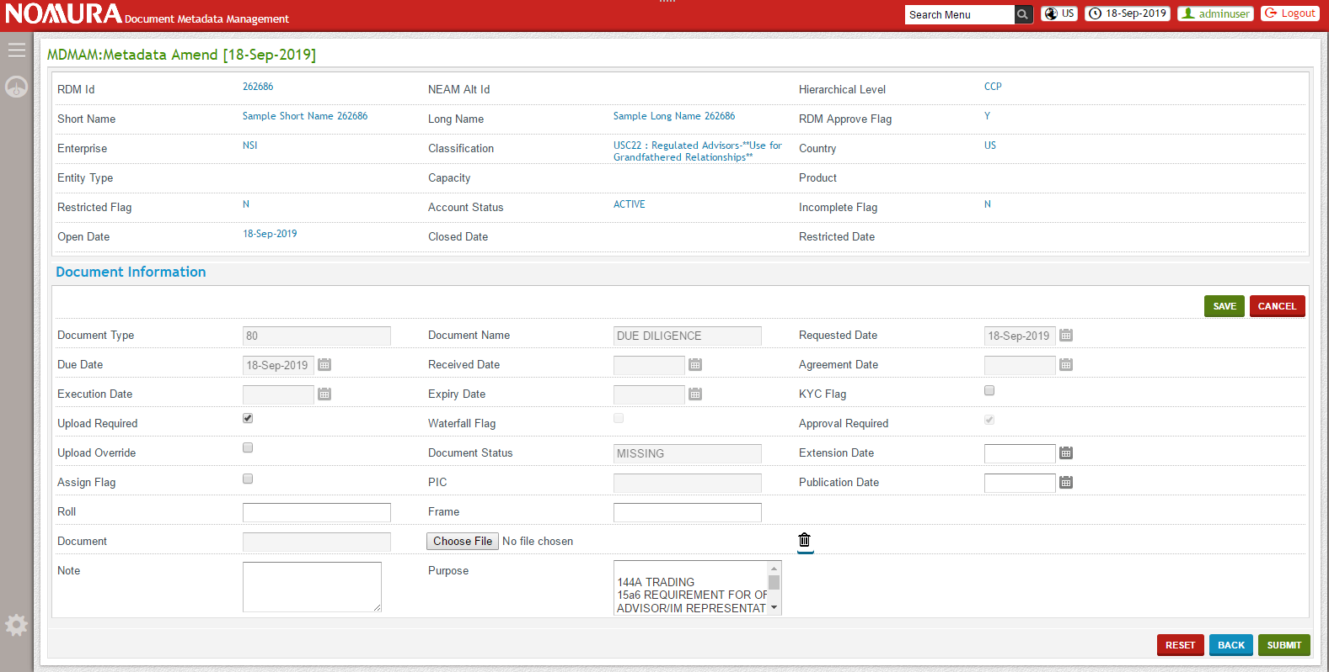

**Metadata Query Layout:**



User can view the meta-data information in the summary based on the query criteria.



### Authorization

|  |  |
| --- | --- |
| **Type** | Online processing - Authorization |
| **Objective of the screen** | These screens are used to query the documents that are in Pending state and approve it. |
| **Standard Operations available** | Query (Y/N)    Y  Entry (Y/N)   Y |
| **Screen Functionality** | **Authorization Query:**   * User can query the documents that are in Pending state using Authorization Query. * This Authorization can be for Association, Documents uploaded, upload override and extension. * User can query with various criteria including RDM id, Hierarchy level, Document type, Document Name, etc. * If the user submits without entering any query criteria, all the pending state associated documents will be displayed in the summary. * If there are no records in DMM for the given query criteria, no results will be displayed in the summary. * User can select one or more Documents and authorize the association, documents upload, upload override and extension. * If the association at CCP level documents is authorized, it should automatically waterfall all the documents to be inherited by the Accounts that belongs to this CCP. This will cancel all the documents for this RDM record and its child records which are not ACTIVE but with same document purpose as the uploaded document and duplicate document type which has Action id as either OUTSTANDING or DELETED. Documents that are waiting for approval will not be cancelled. * If the document upload is authorized, set the document status as ACTIVE, document approved status as APPROVED, due date as empty, extension date as empty. Also cancel all the documents for this RDM record which are not ACTIVE but with same document purpose as the uploaded document and duplicate document type which has Action id as either OUTSTANDING or DELETED. Documents that are waiting for approval will not be cancelled. * If the extension/upload override is approved, set the document approve status as APPROVED. * User can export the result summary in Excel/PDF format. * User can select any RDM id and view its metadata details in a popup. Also user can download the document to verify it. |
| **Access Detail** | Authorized user logs into the system through Single Sign on. |

### Dashboard

|  |  |
| --- | --- |
| **Type** | Dashboard |
| **Objective of the screen** | This screen is used to show the current status of messages and documents in dashboard. |
| **Standard Operations available** | 1. Query (Y/N)    Y 2. Amend (Y/N)         Y |
| **Screen Functionality** | **Expiring documents:**  Document is approaching expiration; it must appear in the Remediation Queue starting at 30 days until expiration. The status of a record should be stored in DMM (active, inactive, restricted, or closed) in order to identify when and if maintenance is required. User can select on the expiring document to take further action such as upload of expiring document with new one. Uploaded documents will be in PENDING state until it is approved.  Document whose approval_required_flag is ‘Y’, i.e., documents created based on rule only will appear in the queue. If the document is assigned to a person, then it will not show up in other persons queue.   * Documents Expired * User can view documents that are expired for ACTIVE accounts. * Once the Document action is approved to be UPLOAD_OVERRIDE, it will not be shown in the dashboard even if the document is expired. * Once Extension Date is provided, the document will not be shown in the dashboard until the extension date is crossed even if the document is expired * Documents expiring in 15 days * User can view the number of documents expiring in 15 days in Expiring Documents widget. * Documents expiring in 30 days * User can view the number of documents expiring in 1 month in Expiring Documents widget.   **Grace period closing**  Documents with grace period ending will appear in the Remediation Queue starting at 30 days until end date. User can select the grace period ending document type and upload document for it. Uploaded documents will be in PENDING state until it is approved.  Document whose approval_required_flag is ‘Y’, i.e., documents created based on rule only will appear in the queue. If the document is assigned to a person, then it will not show up in other persons queue but will show up only in the assigned persons queue.   * Grace period ended * Shows the number of documents that expired with grace period ended for ACTIVE accounts. * Once the Document action is approved to be UPLOAD_OVERRIDE, it will not be shown in the dashboard even if the document is grace period ended. * Once Extension Date is provided, the document will not be shown in the dashboard until the extension date is crossed even if the document is grace period ended. * Grace period ending in 15 days * Shows the number of documents about to expire with grace period in 15 days. * Grace period ending in 30 days * Shows the number of documents about to expire with grace period in 30 days.   **Missing documents**  Documents that are missing for ACTIVE accounts will appear in the Remediation Queue. User can select the missing document type and upload document for it. Uploaded documents will be in PENDING until it is approved.  Document whose approval_required_flag is ‘Y’, i.e., documents created based on rule only will appear in the queue. If the document is assigned to a person, then it will not show up in other persons queue but will show up only in the assigned persons queue.   * Once the Document action is approved to be UPLOAD_OVERRIDE, it will not be shown in the dashboard even if the document is missing. * Once Extension Date is provided, the document will not be shown in the dashboard until the extension date is crossed even if the document is missing.   **Extension documents**  Shows the number of documents Extended and their extension date is not yet reached. Documents manually added in DMM and created based on rule will be appearing in the dashboard if it has extension. If the document is assigned to a person, then it will not show up in other persons queue but will show up only in the assigned persons queue.  **Documents for Approval**  Shows the number of documents that are waiting for approval. This includes approval for Association, Document upload, upload override and extension.  **Restricted Accounts**   * User can view the number of accounts restricted in Restricted Accounts widget. * User can select the accounts restricted and view its details that will be displayed in the summary.   **Operational load queue**   * User can view the number of trade violations happened during trade using trading account no and trade type.   **Processed Data**  User can view number of messages processed in DMM on daily basis. No further actions can be executed on them.   * Processed RDM Account Message * Shows the total number of RDM account messages processed for the day. * Processed RDM organization message * Shows the total number of RDM organization messages processed for the day.   **Errors**   * Unprocessed RDM Account Message * Shows the total number of RDM account messages that is not processed successfully due to exceptions for the day. * Unprocessed RDM organization message * Shows the total number of RDM organization messages that is not processed successfully due to exceptions for the day. |
| **Access Detail** | Authorized user logs into the system through Single Sign on. |

**Dashboard Layout**

User preferred widgets will be displayed here.

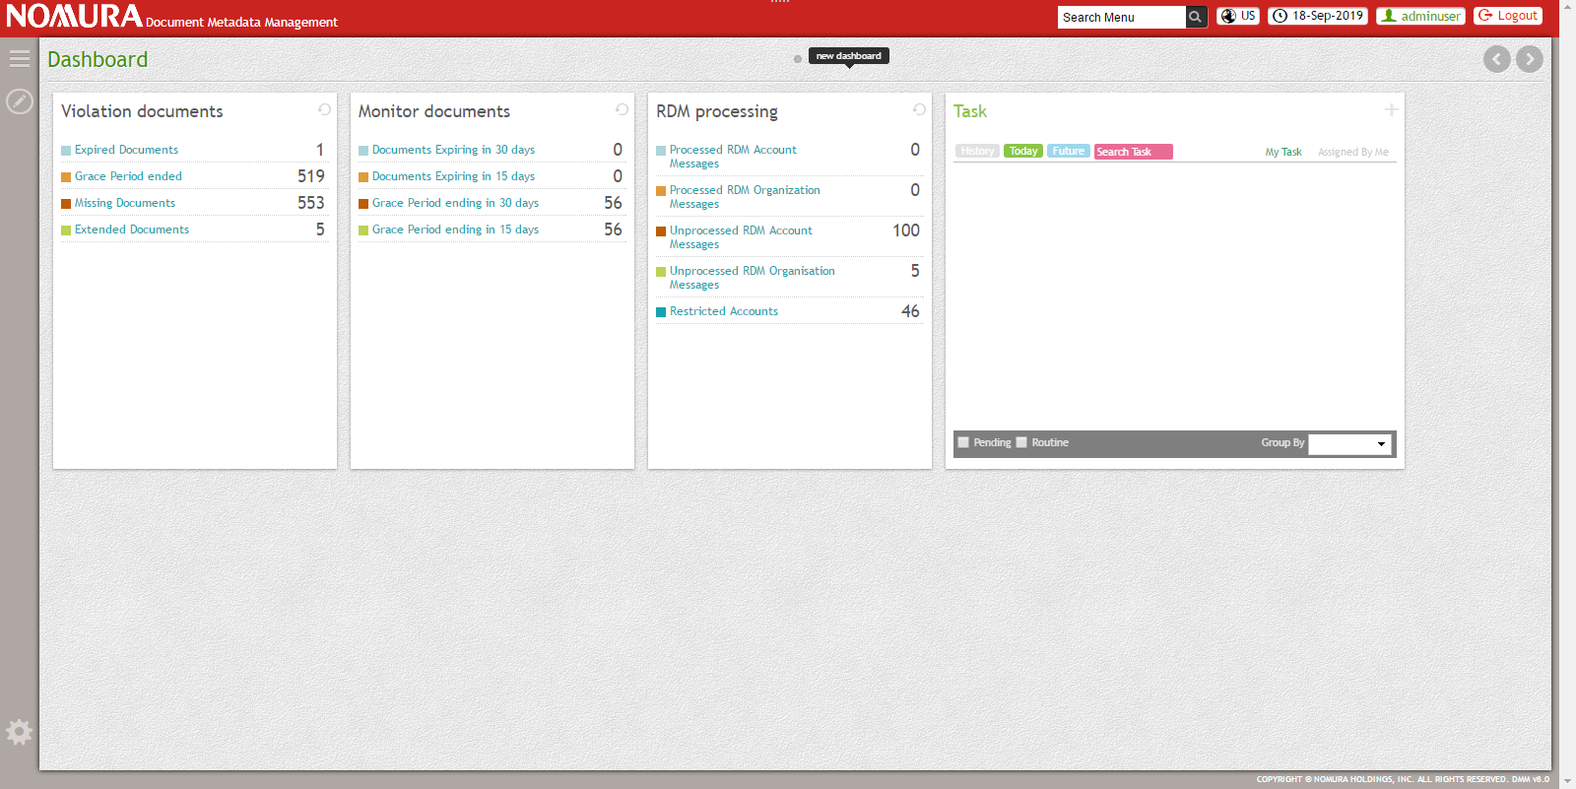

User can enter the current status for each document.

## Administration online processing

### Rule maintenance (add / amend / delete)

|  |  |
| --- | --- |
| **Type** | Administration online processing - Rule maintenance |
| **Objective of the screen** | This screen is used to enter, query and amend the Rules. |
| **Standard Operations available** | 1. Entry (Y/N)     Y 2. Query (Y/N)    Y 3. Amend (Y/N)         Y 4. Cancel (Y/N)       Y |
| **Screen Functionality** | **Entry:**   * Two types of Rules are maintained using this screen.   + Service Rule – Define Service criteria (Enterprise Id, Classification, Capacity, Product, trade type etc. based on rule type) and associating list of documents to it.   + Document Rule – Define rule criteria (Expiry Flag, Grace Period, Expiration Period, etc.) for each document type. * User can build service rule based on 6 different rule types. They are   + Classification Rule   + Entity Rule   + Country rule   + Product rule   + Client Capacity rule   + Trade Type rule * User can build service rule by associating any number of available document type which needs to be applied to all of its instances i.e., to all the Accounts/CCP/LCP that have matched the service criteria. * If User could not find the required document type in the existing document type list, User can create a new Document Type with document rule definition and associate it with service. * For defining document rule, by default,   + Grace period will be null (No grace period).   + Expiring Flag will be N.   + Expiration period will be ‘0’ days. * Document rules will be used to decide the Document Status (Expired/Grace Period Ended/ Missing) when it is linked with an Account/CCP/LCP. * Document rules will be used to configure Grace Period, Expiry flag, Expiration Period and Upload required. * Whenever a new Account/CCP/LCP is registered in DMM, the list of documents required for it will be built using service rules.   **Query:**   * Users can query the rules and test various scenarios of document requirements before onboarding a CCP, LCP, or Account using Rule Management Query. * User can query with various criteria including Enterprise Id, Classification, Country, Product, Client Capacity, etc. and test the document required for the given criteria. * User can also query by providing the rule type. * If the user submits without entering any query criteria, all the service rules will be displayed in the summary. * If there are no records in DMM for the given query criteria, no results will be displayed in the summary. * User can export the result summary in excel/pdf format. * User can select and view any service/document and view its rule details in a popup.   **Amend:**   * User can choose any service/document type to amend its rules. * When user selects service rule for amendment, * User can associate/dissociate any documents for the defined service criteria. * User cannot amend the service criteria. * When user selects document rule for amendment,   + User can amend the document rule (Expiry Flag, Grace Period, Expiration Days, etc.)   + Document status based on the amended document rule will be reflected only for future documents. |
| **Access Detail** | Authorized user logs into the system through Single Sign on. |

**Entry Screen Layout**

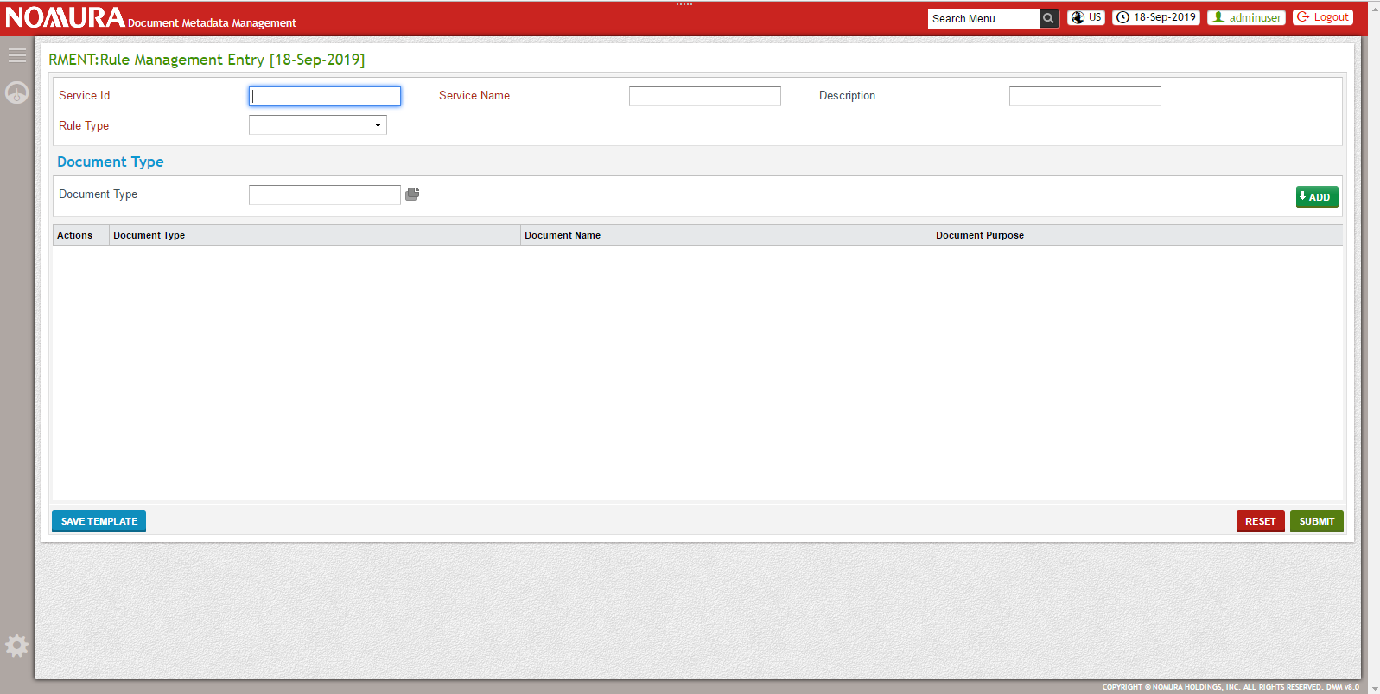

User can maintain the rule based on service level based on list of documents with its own rules.

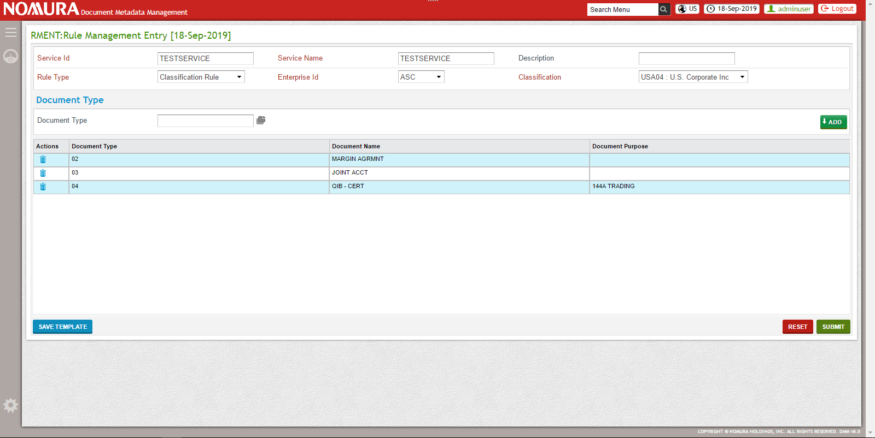

**Query Screen Layout**

User can query the rules based on service level or document level.

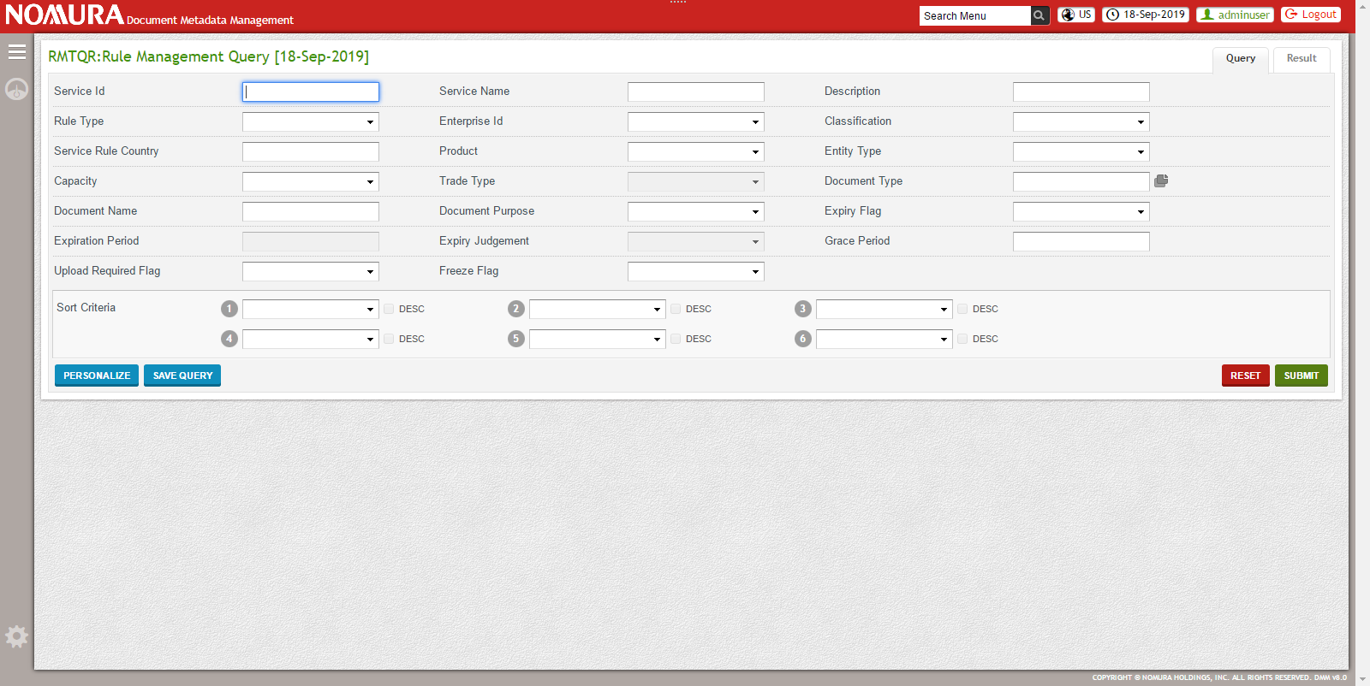

User can view the rules in the summary based on the query criteria.



**Amend Screen Layout**

User can edit the rules based on the requirement.

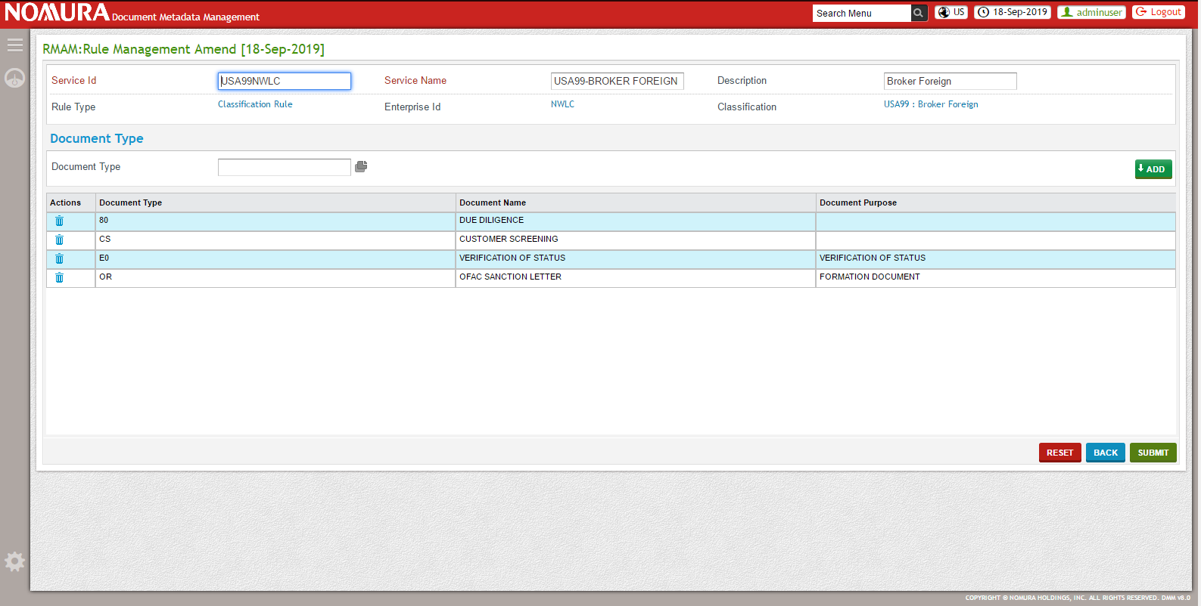

### User group maintenance

|  |  |
| --- | --- |
| **Type** | Administration online processing – User group maintenance |
| **Objective of the screen** | This screen is used to enter, query, amend or cancel the application roles. |
| **Standard Operations available** | 1. Entry (Y/N)     Y 2. Query (Y/N)    Y 3. Amend (Y/N)         Y 4. Cancel (Y/N)       Y |
| **Screen Functionality** | **Entry:**   * In DMM, User roles are maintained at Legal Entity (Enterprise Id) level. * The objective of this feature is to let a user create an application role from the UI for a Legal Entity and associate it with different menus and widget along with its set of pre-defined feeds if there are any. * Application role ensures that a transactional record associated with a particular enterprise or region should be accessible within the domain of that particular enterprise or region respectively. * Through Application Role entry screen, User can enter the Application role name, select the enterprise, select the menu for which access needs to be given and select the Dashboard/widget for which access needs to be given.   **Query:**   * User can query with various criteria including Application Role Name, Status, Enterprise Id, etc. * If the user submits without entering any query criteria, all the User roles will be displayed in the summary. * If there are no records in DMM for the given query criteria, no results will be displayed in the summary.   **Amend:**   * User can query the application role and select any application role to amend its details. * User can amend the menu restriction and Dashboard/Widget restriction through this screen.   **Cancel:**   * User can query the application role and select any application role to cancel it. * When a user logs in with the cancelled application role, access provided by that application role will be restricted. |
| **Access Detail** | Authorized user logs into the system through Single Sign on. |

**Application Role Entry Screen Layout:**

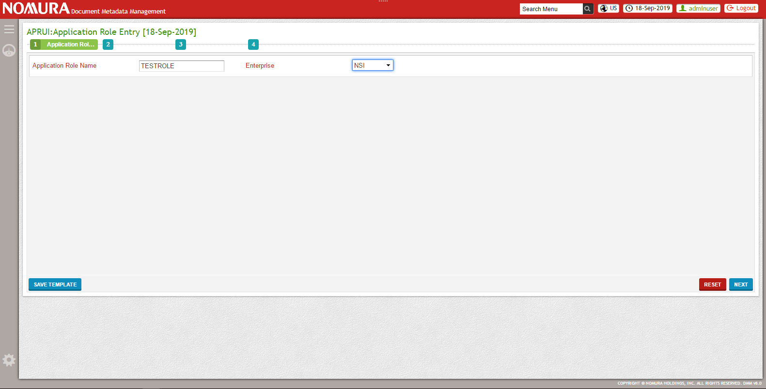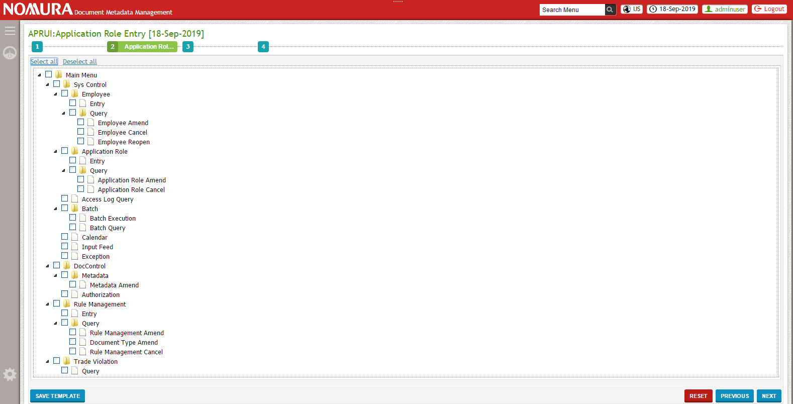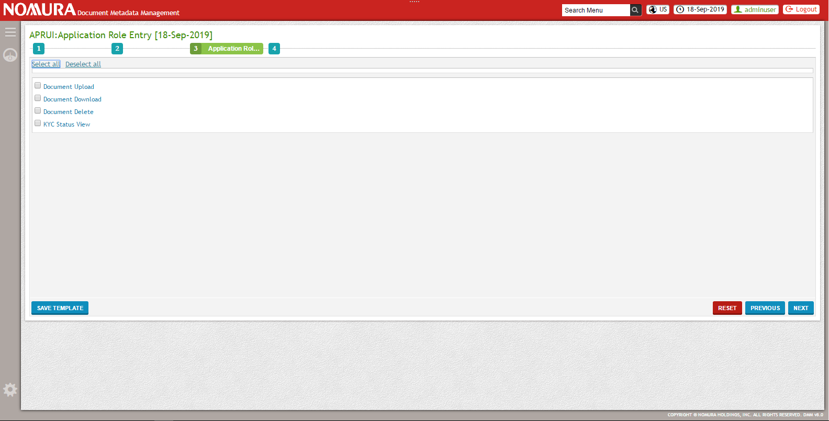

User can create the roles to define the limits for the user.

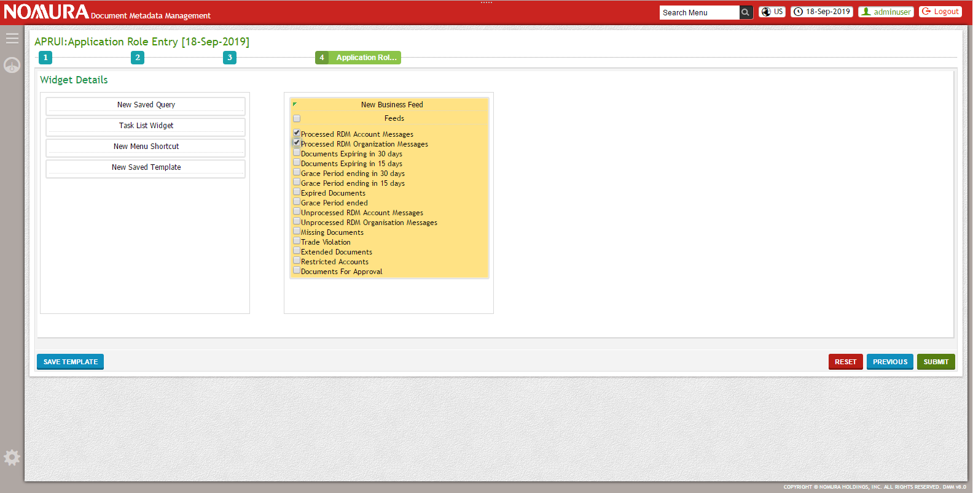

**Application Role Query Screen Layout:**

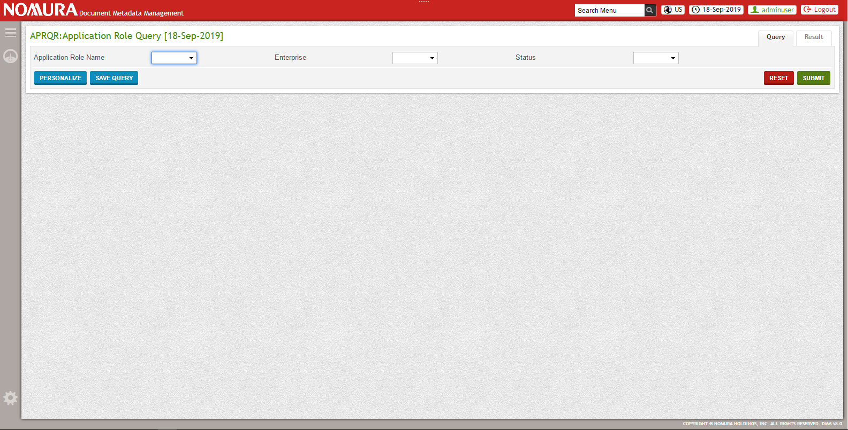

User can view the list of roles in the summary.

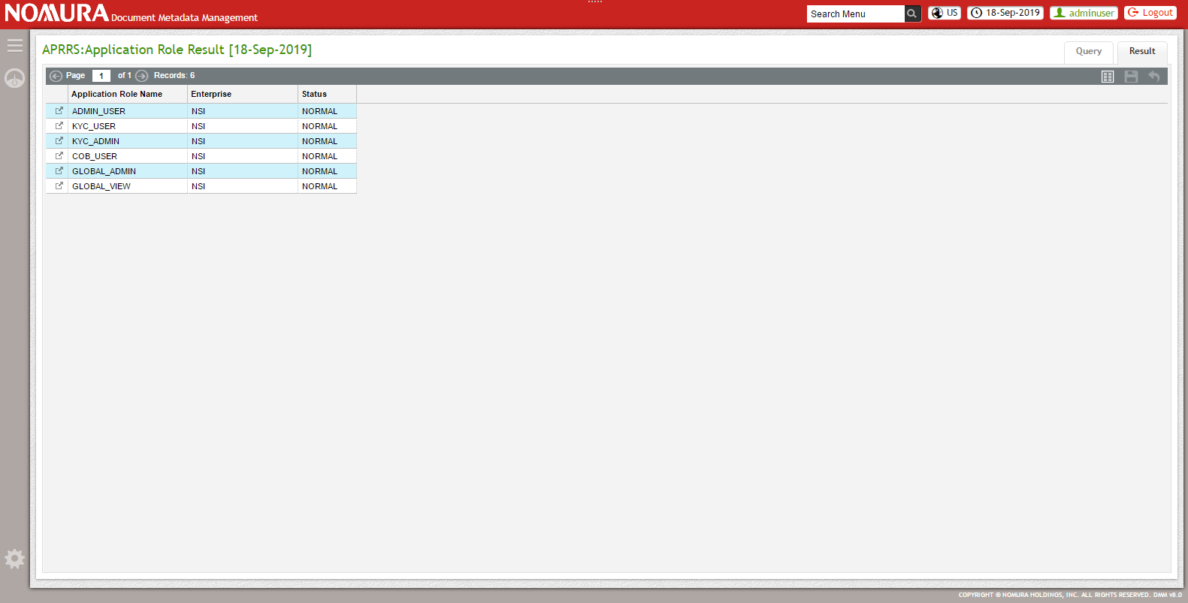

**Application Role Amend Screen Layout:**

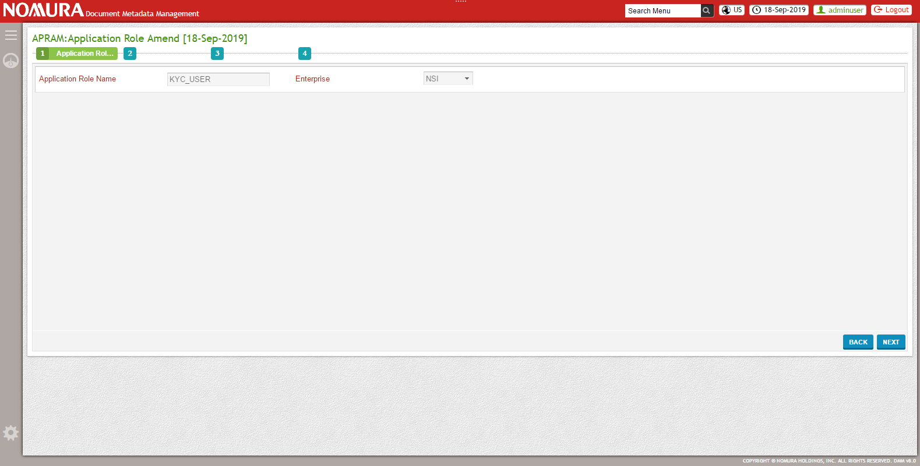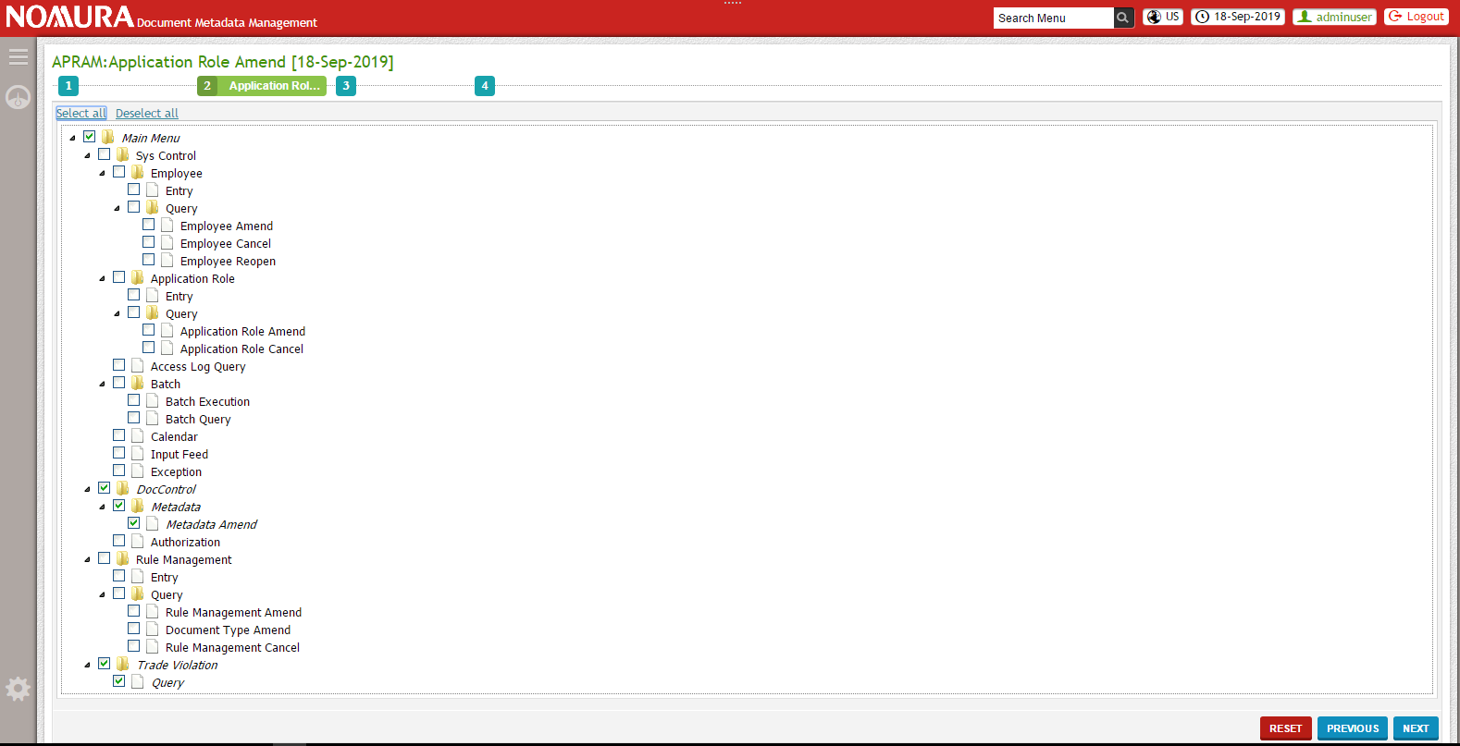

User can edit the role features based on the requirement

**Application Role Cancel Screen Layout:**

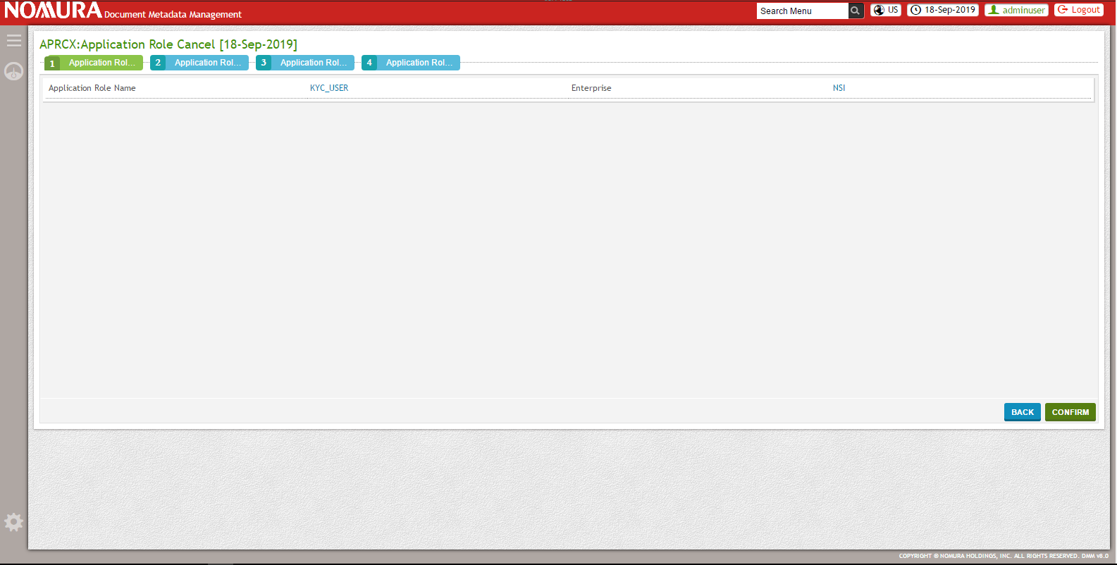

User can cancel the role.

### User maintenance

|  |  |
| --- | --- |
| **Type** | Administration online processing – User maintenance |
| **Objective of the screen** | This screen is used to enter, query, amend or cancel the User. |
| **Standard Operations available** | 1. Entry (Y/N)     Y 2. Query (Y/N)    Y 3. Amend (Y/N)         Y 4. Cancel (Y/N)       Y |
| **Screen Functionality** | **Entry:**   * Create User using this User Entry screen. * In DMM, only basic user information will be maintained. * User can be linked with one or more application role based on which user gets the access to Menu and Dashboard/widgets.   **Query:**   * User can query with various criteria including User Id, Name, Email id, etc. * If the user submits without entering any query criteria, all the User details will be displayed in the summary. * If there are no records in DMM for the given query criteria, no results will be displayed in the summary. * User can export the result summary in Excel/PDF format. * User can select any User Id and view its details in a popup.   **Amend:**   * User can query the user details and select any user to amend its details. * User can amend the basic user information and add/remove any application role linked to that user.   **Cancel:**   * User can query the user details and select any User id to cancel it.   **Reopen:**   * User can query the user details and select any closed user’s User id to reopen it. |
| **Access Detail** | Authorized user logs into the system through Single Sign on. |

**User Entry Screen Layout:**

User can create the user for the enterprises.

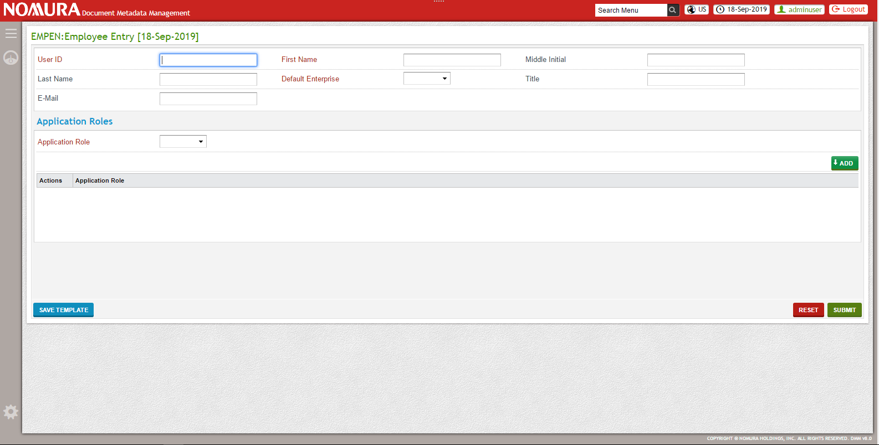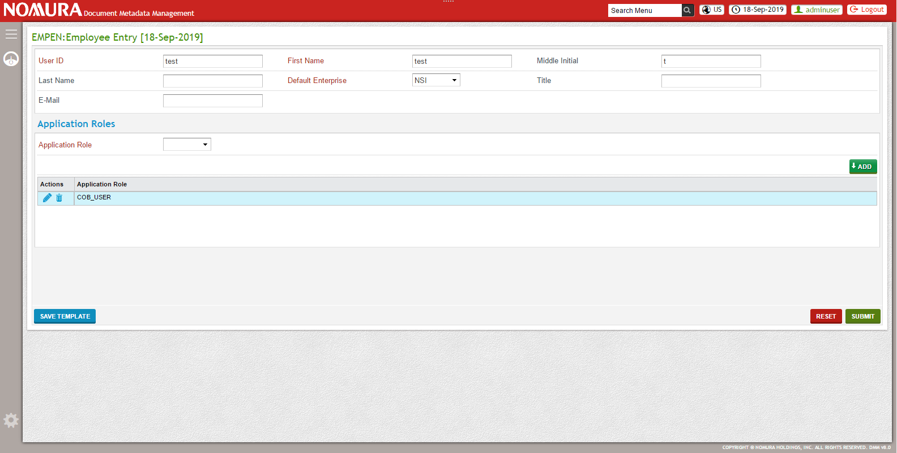

**User Query Screen Layout:**

User can query the users based on the enterprise, User Id, Employee Name or Email Id.

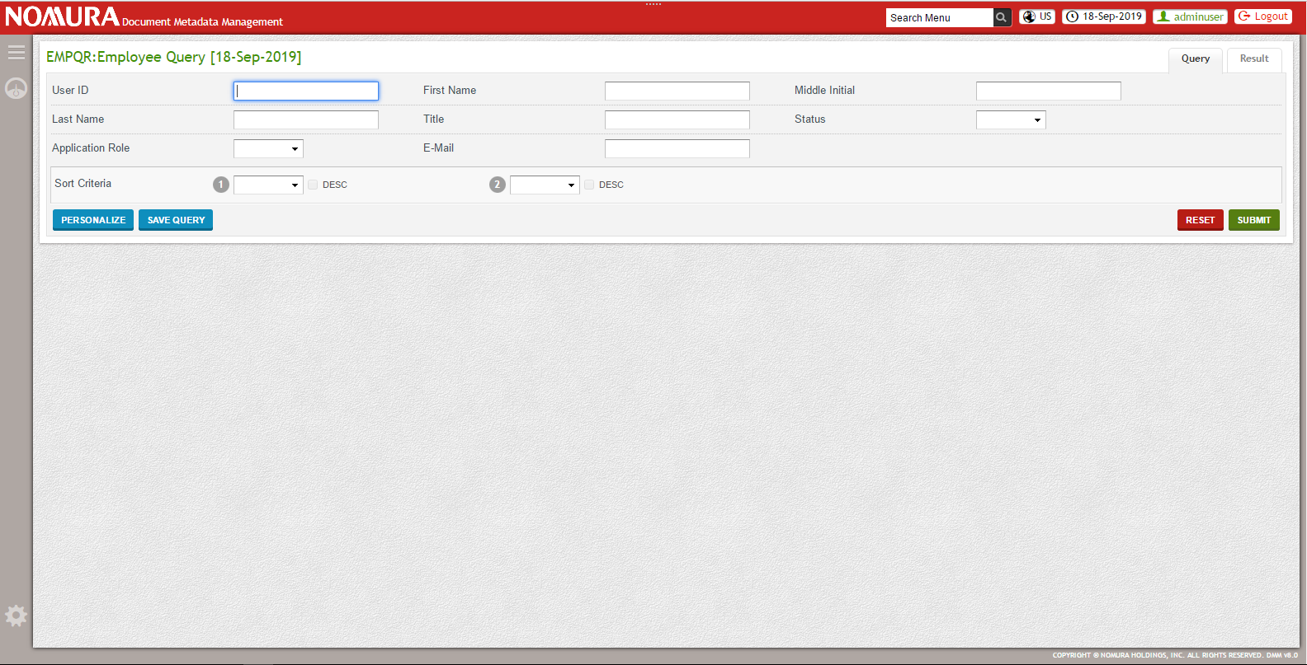

User can view the list of user in the summary based on the query criteria.

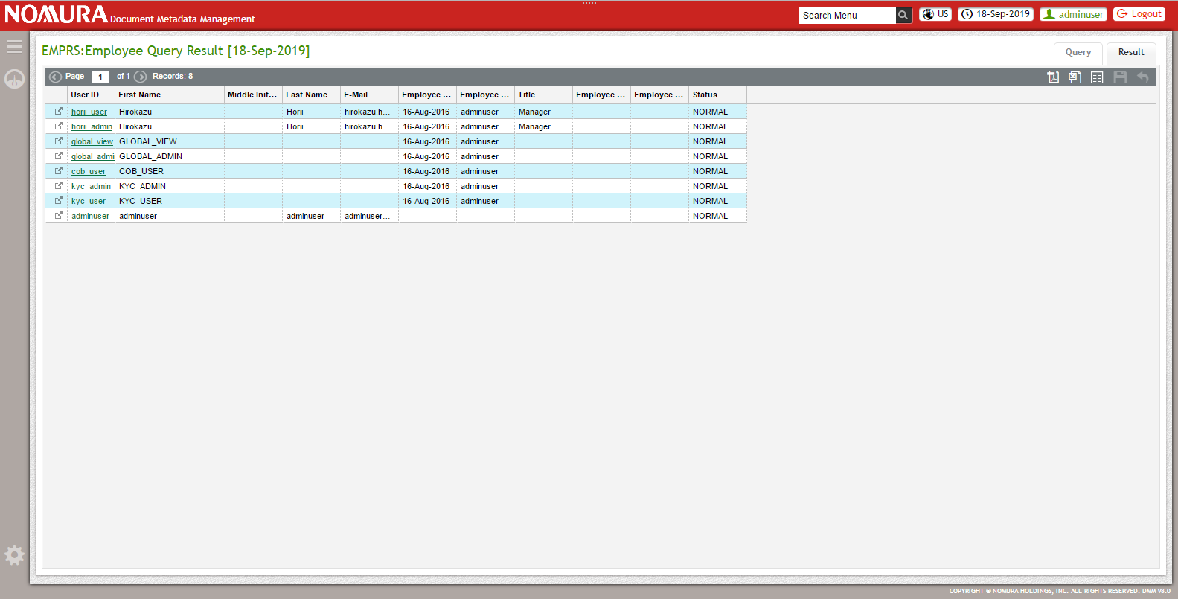

**User Amend Screen Layout:**

User can edit the details of the user based on the requirement.

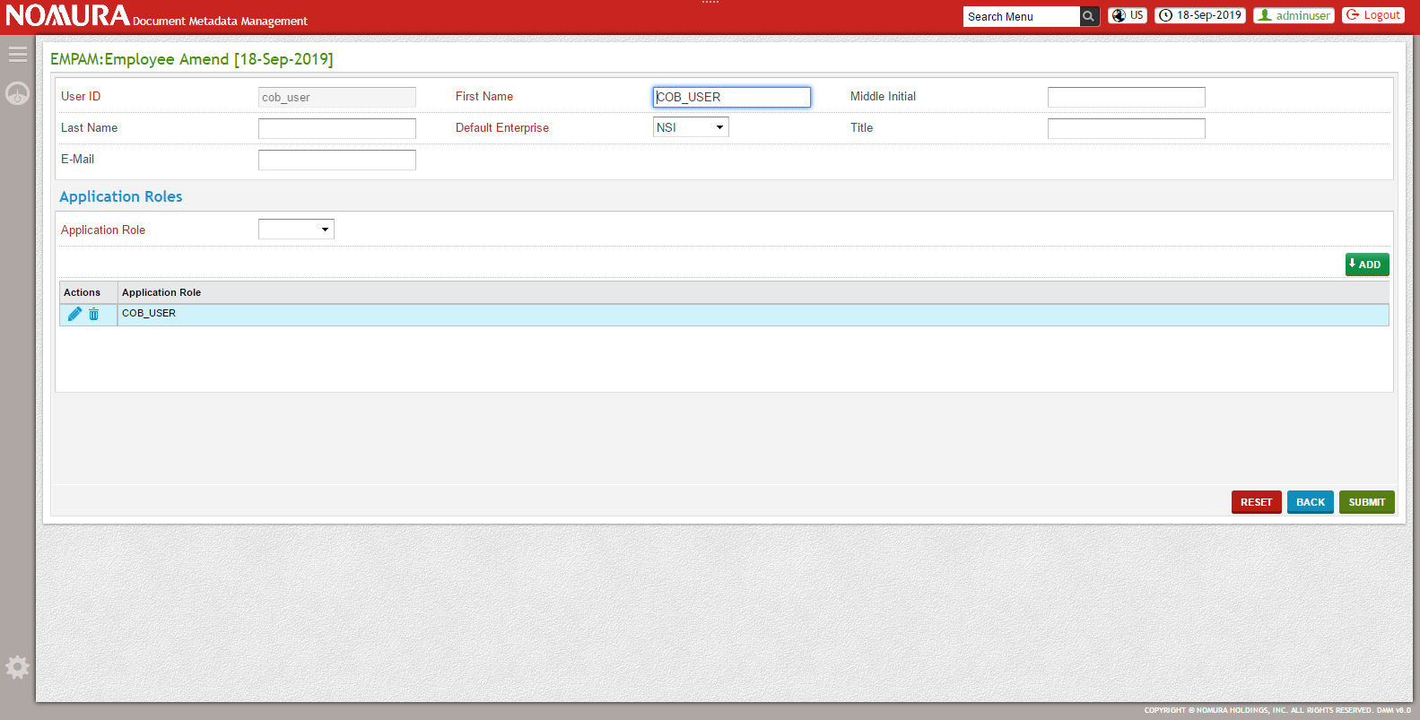

**User Cancel Screen Layout:**

User can cancel the user.

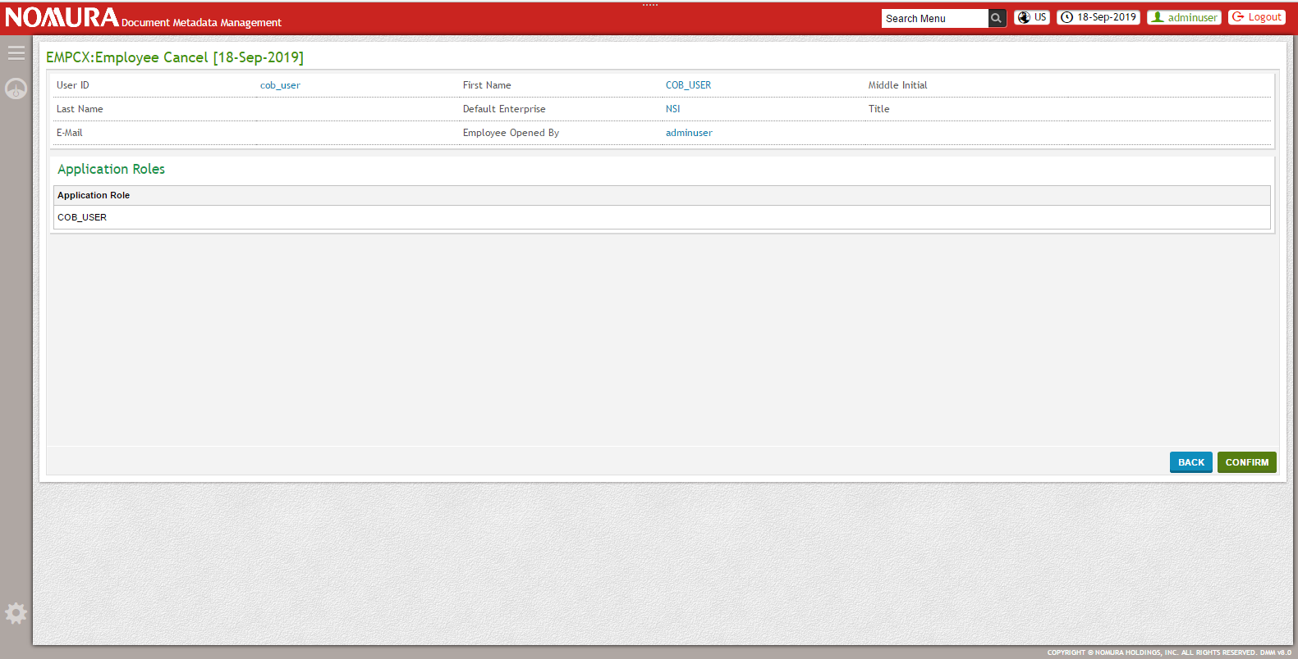

**User Reopen Screen Layout:**

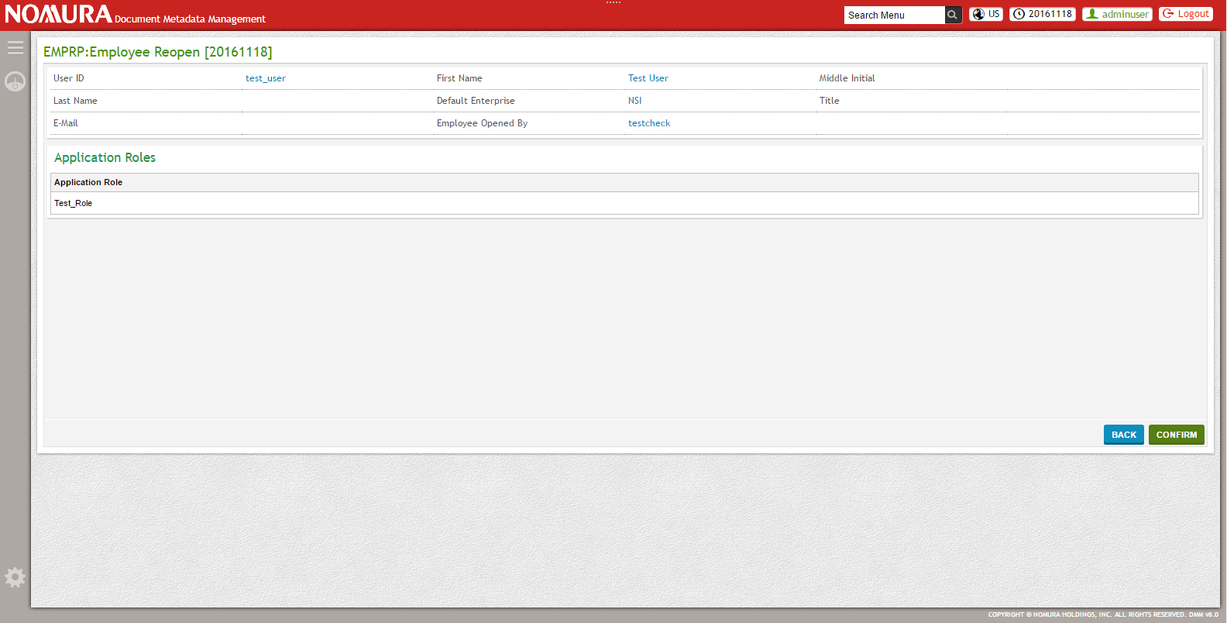

## Services and background processes

### RDM & NEAM messages load

Logical flow to handle RDM account message and RDM org message

Logic flow to handle NEAM request message

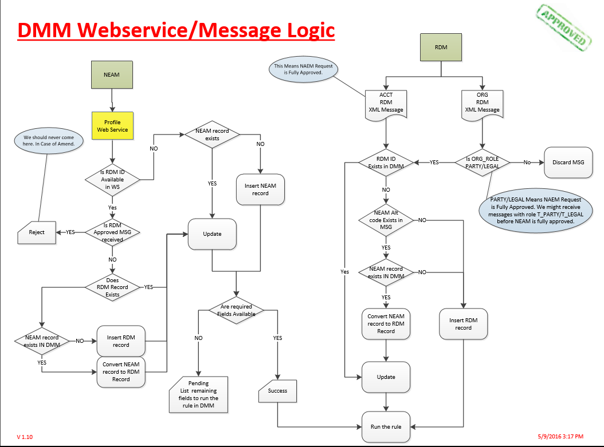

#### RDM messages load

|  |  |
| --- | --- |
| **Source** | RDM Message Queue (IBM Queue) |
| **Mode** | Background Process |
| **Purpose** | DMM should consume message from RDM using IBM MQ and store the RDM information in DMM. |
| **Input** | * Account Open Message * Account Close Message * Account Update Message * Organization Open Message * Organization Update Message |
| **Data Conditions** | * DMM consumes message from RDM using IBM MQ. * RDM Organization message with T_PARTY or T_LEGAL as role will be ignored. * If the CCP has none or more than one valid DMM classification code, then this will be considered as incomplete and registered in DMM. Incomplete_flag will be set as ‘Y’. Rules will not be executed for this record. * If an Account has none or more than one valid DMM classification code, then error will be thrown and will not be stored in DMM. * Rule execution will happen only for RDM records with status as ACTIVE and incomplete_flag as ‘N’. * If there is a Status change from INACTIVE to ACTIVE or from CLOSED to ACTIVE or the incomplete_flag changed from ‘Y’ to ‘N’, re-execute the rules based on the current service criteria information available. * If the document type status is MISSING or GRACE_PERIOD_ENDED or if the action id is OUTSTANDING, then reset the requested date to current date, calculate due date based on requested date and calculate document status based on requested date and due date. * If the document type status is EXPIRED, UPLOAD_OVERRIDE, EXTENDED then reset requested date to current date, calculate due date based on requested date, calculate document status based on requested date and due date. Also in addition, change the action id to OUTSTANDING, and clear values in received_date, execution_date, agreement_date, extension_date and note. Existing values can be tracked through audit history. * If the document type status is ACTIVE we do nothing. * If the RDM Id already exists in DMM, update the RDM data in DMM and re-run the rule. * If the RDM Id does not exists in DMM and no NEAM-Alt code present in RDM message, create a new RDM record and run the rule. * If the RDM Id does not exists in DMM and NEAM-Alt code present in RDM message, but NEAM ID is not registered in DMM, create a new RDM record and run the rule. * If the RDM Id does not exists in DMM and NEAM-Alt code present in RDM message which is registered in DMM, convert NEAM id to RDM id and update other information for the record and re-run the rule. * To re-run the rule to identify the list of documents required based on the updated fields. Cancel the existing document records for which document is not yet received, but created earlier and not required as per the current rule. Create new document records for document types that does not exist earlier. * By default, Action status of the created new document record will be as 'Outstanding', If user uploads the corresponding document, then it will be changed to 'Received' * If there is any status update in RDM, DMM will receive the message with updated status (active, restricted, inactive, and closed) from RDM. Restricted status Account will be shown in Dashboard. * If the RDM data (Account ID) is closed, DMM will receive a RDM Close message from RDM, and the status will be automatically updated as 'closed'. * For each message received from RDM need to check classification and run classification rule; country and if exists in rule set, need to run country rule; product and if exists in rule set, need to run product rule; capacity and if AGENT, need to run AGENT rule; entity type and if exists in rule set, need to run entity type rule. |
| **Frequency** | Real time |
| **Message Format** | Xml Message |
| **Validation** | * If DMM could not identify any service for the criteria from RDM message, RDM message will be loaded with no rules executed. |

#### NEAM messages load

|  |  |
| --- | --- |
| **Source** | Web service request |
| **Mode** | On Request |
| **Purpose** | NEAM requests DMM to register Account/CCP/LCP information in it. |
| **Input** | * Request with attributes |
| **Data Conditions** | * NEAM requests DMM with required fields and NEAM id to register the Account/CCP/LCP in DMM. * If the request contains RDM ID which is already approved from RDM, reject the message. * If the request contains RDM ID which is not yet approved from RDM, but RDM record exists in DMM, update the RDM record and re-run the rule. * If the request contains RDM ID which is not yet approved from RDM and no RDM record exists for this RDM id in DMM, but the NEAM record exists in DMM then convert the NEAM record to RDM record, update the RDM record and re-run the rule. * If the request contains RDM ID which is not yet approved from RDM and no RDM record exists for this RDM id in DMM, also the NEAM record does not exists in DMM then create a new RDM record and run the rule. * If the request does not contain RDM ID and if the NEAM ID present in request is also not available in DMM, create a new record with NEAM ID and run the rule. * If the request does not contain RDM ID and if the NEAM ID present in request is already available in DMM, update the modified fields and re-run the rule. * To run the rule for the first time, using the attributes of NEAM/RDM record identify the service and its list of documents. Create a new document record with Action status as ‘OUTSTANDING’ for each identified document. * To re-run the rule, identify the list of documents required based on the updated fields. Cancel the existing document records for which document is not yet received, but created earlier and not required as per the current rule. Create new document records with Action Status as ‘OUTSTANDING’ for document types that does not exist earlier. * If the CCP has none or more than one valid DMM classification code, then this will be considered as incomplete and registered in DMM. Incomplete_flag will be set as ‘Y’. Rules will not be executed for this record. * If an Account has none or more than one valid DMM classification code, then error will be thrown and will not be stored in DMM. * If there is a change in incomplete_flag from ‘Y’ to ‘N’, then re-execute the rules based on the current service criteria information available. * If the document type status is MISSING or GRACE_PERIOD_ENDED or if the action id is OUTSTANDING, then reset the requested date to current date, calculate due date based on requested date and calculate document status based on requested date and due date. * If the document type status is EXPIRED, UPLOAD_OVERRIDE, EXTENDED then reset requested date to current date, calculate due date based on requested date, calculate document status based on requested date and due date. Also in addition, change the action id to OUTSTANDING, and clear values in received_date, execution_date, agreement_date, extension_date and note. Existing values can be tracked through audit history. * If the document type status is ACTIVE we do nothing. * For each message received from RDM, need to check classification and run classification rule; country and if exists in rule set, need to run country rule; product and if exist in rule set, need to run product rule; capacity and if AGENT need to run AGENT rule, entity type and if exist in rule set, need to run entity type rule. |
| **Frequency** | Real time |
| **Message Format** |  |
| **Validation** | None |

### Takara Message Creation

|  |  |
| --- | --- |
| **Purpose of the batch** | This background process will be executed to generate xml message for each document record to be transmitted to TAKARA. |
| **Output Format** | XML Message |
| **Output System** | Takara |
| **Medium** | TIBCO MQ |
| **Data Conditions** | * This process feeds the metadata information into TAKARA system to enable proactive trade-prevention or account opening blocks in the future state. * This process generates an XML message whenever there is a change in metadata which is in Approved state or the status changes to/from Approved state. |
| **Frequency** | Real time |
| **Validation** | None. |

## Batch processing

### Document Expiration

|  |  |
| --- | --- |
| **Purpose of the batch** | This batch will be executed to decide the status of the document that will be used to show in Dashboard. |
| **Input Format** | None |
| **Input System** | None |
| **Medium** | None |
| **Data Conditions** | * Document status will set as ‘Expired’ when the current date exceeds Expiration date of the document. * Document status will be set as ‘Missing’ when the ‘Grace Period’ for the document is ‘0’ and if the document is not available in DMM. * Document status will be set as ‘Grace Period Ended’ when the ‘Grace Period’ for the document is not equal to ‘0’ and if the current date exceeds Due date of the document. |
| **Frequency** | End of Day |
| **Validation** | None. |

### Data Legal Update

|  |  |
| --- | --- |
| **Purpose of the batch** | This batch consumes a file from Data Legal and create or update document record for LCP, based on the input file. |
| **Input Format** | Pipe ‘|’ delimited dat File |
| **Input System** | Data Legal |
| **Medium** | FTP |
| **Data Conditions** | * This batch consumes a file from Data Legal. The file must contain LCP Id and documents record related to it. * These document records for LCP will be created/ updated based on the input file. * Data legal documents are by default waterfall flag enabled, hence it will be automatically waterfall to all its sub accounts. * Data legal document with archive date will be identified using agreement id (Document id in DMM) and cancelled in DMM. * This batch should be executed before Trade files Consumer Batch. |
| **Frequency** | End of Day |
| **Validation** | If any record from Data legal input file could not be processed successfully, then the record will be considered as an error record and will be written in a separate error file. |

### Trade File Loading

|  |  |
| --- | --- |
| **Purpose of the batch** | This process loads the Trade file received from NCDI into DMM. |
| **Input Format** | Pipe ‘|’ delimited dat File |
| **Input System** | NCDI |
| **Medium** | FTP |
| **Data Conditions** | * This batch consumes the file from NCDI. The file must contain trade type, trade date and trading account RDM id. * If duplicate record found for the same trade type, trade date and trading account RDM id, it will be skipped and not loaded in DMM. * Trade file loading should be followed by Trade exception status update batch. |
| **Frequency** | End of Day |
| **Validation** | None. |

### Trade Exception Status Update

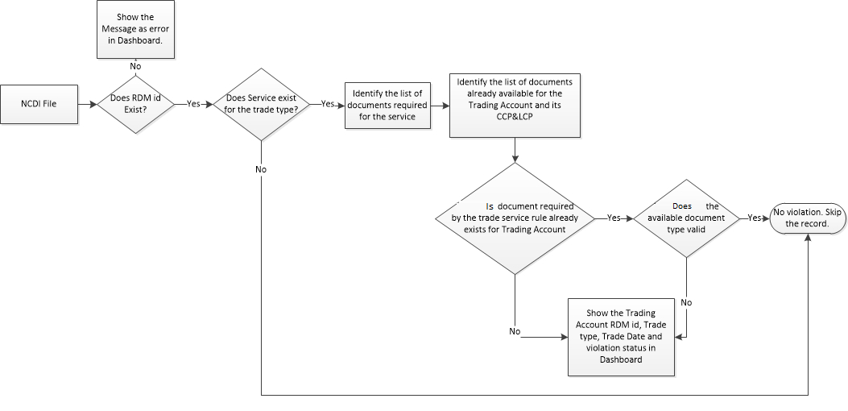

|  |  |
| --- | --- |
| **Purpose of the batch** | This batch is used to identify the trades that violated trade rule for Accounts in DMM. |
| **Input Format** | None |
| **Input System** | None |
| **Medium** | None |
| **Data Conditions** | * Trade rules in DMM will be executed on Trade data and violation status will be decided and shown in dashboard. * If all the documents required for trade type are available for the Account in ACTIVE state, set Trade Violation status as ‘CLEAR’ else set as ‘VIOLATION’. * If the RDM id received from NCDI is not present in DMM, set the violation flag as ERROR. * VIOLATION and ERROR record will be considered every time when the batch is executed until it gets CLEAR. |
| **Frequency** | End of Day |
| **Validation** | If the RDM id from NCDI is not present in DMM, the record will be thrown as exception and shown in dashboard. |

### Downstream loads

#### DMM to RDM Restriction File Generation Batch

|  |  |
| --- | --- |
| **Purpose of the batch** | This batch will be executed to generate a ‘|’ delimited dat file to be sent to RDM. |
| **Output Format** | ’|’ delimited dat file |
| **Output System** | RDM |
| **Medium** | FTP |
| **Data Conditions** | * This batch generates two pipe ‘|’ delimited dat file, one for Account and the other for CCP with RDM id and reason for restriction detail in it. * Document whose status is decided as ‘Missing’, ‘Expired’ and ‘Grace Period Ended’ on current day beginning and whose Freeze flag is ‘Y’, only these details will be sent to RDM. * This file is sent to RDM through FTP every end of day. * It is used in RDM side to decide the Restriction Status. |
| **Frequency** | End of Day |
| **Validation** | None. |

#### TAKARA Daily Dump File Creation

|  |  |
| --- | --- |
| **Purpose of the batch** | This batch will be executed to generate pipe ‘|’ delimited dat file with the details about the metadata information |
| **Output Format** | Pipe ‘|’ delimited dat file |
| **Output System** | Takara |
| **Medium** | FTP |
| **Data Conditions** | * This batch feeds the metadata information into TAKARA system as a dump since TAKARA does not have any DB. * This batch generates a pipe’| delimited dat file with all the metadata which is in Approved state * This batch should be scheduled to run once a day or week. |
| **Frequency** | Daily or Weekly **(TBD)** |
| **Validation** | None. |

### Rule Execution Batch

|  |  |
| --- | --- |
| **Purpose of the batch** | This batch executes service rule for the existing Account/CCP/LCP. |
| **Input Format** | None |
| **Input System** | None |
| **Output Format** | None |
| **Output System** | None |
| **Medium** | None |
| **Data Conditions** | * This batch takes a date, Service Id, RDM id and hierarchical level as arguments. * If service id is given, this batch executes this service rule for all its corresponding Account/CCP data. * If both service id and date is given, this batch executes rule for all its corresponding Account/CCP data with this service and has open date after the given date. * If RDM Id and hierarchical level is given, then rule will be executed for that particular RDM Id. * This batch can be executed from UI screen also. |
| **Frequency** | If required. |
| **Validation** | None |

## Assumptions (Applicable for Phase 1)

|  |  |
| --- | --- |
| **Ref** | **Assumptions** |
| A-1 | The DMM would need to support only the US Documentum |
| A-2 | As authorization queue is planned to be implemented for phase 2, validating the access to documents via the authorization queue is not covered in Phase 1. |
| A-3 | No other systems will be integrated in DMM other than the ones shown in the system overview diagram |
| A-4 | Export of documents to a single zip file is out of scope |
| A-5 | Booking Entity that deals with syncing documents used across multiple regions is not covered in this phase 1 |
| A-6 | Field level restriction is out of scope |
| A-7 | Purge functionality to delete from Documentum is not covered in phase 1 |
| A-8 | Nomura Now is not considered for DMM (It is covered via Takara load) |
| A-9 | Bulk import of documents is out of scope |
| A-10 | All Obligor related information mentioned in the FSD are not phase 1 and they will be covered in the next phases. |
| A-11 | All functional requirements are expected to be frozen by April end. The Requirement changes that come after May 2nd, would need to be handled through the Change Management process |
| A-12 | Screen images used in this document is subject to change. This is not the final screen image. |

## Dependencies

|  |  |
| --- | --- |
| **Ref** | **Dependencies** |
| D-1 | During the development phase during the months of May and June, it is required to have access to TIBCO queue for development and testing of NEAM message consumer and KYC status consumer in case TIBCO queue is going to be used for the communication between NEAM and DMM & ACE and DMM |
| D-2 | Instances of Real time environment such as the Documentum instance needs to be available during the QA Testing stage that is expected to be in the month of July - August |
| D-3 | Real Data (Masked) from Data Legal, rules etc need to be available during the functional testing phases that would be during the months of May and June |
| D-4 | All the definitions and the Interface details to be finalized before the detailed design stage. Any changes in these interface details during the course of the project would affect the overall schedule of the project |

# Non-functional requirements

## UI Performance & Language support

|  |  |  |
| --- | --- | --- |
| **Ref** | **Requirements** | **Remarks** |
| P-1 | “Response Time” must stay under 1 second | UI response time would be under 1 sec |
| P-2 | The Language support to be English only | English language support only will be tested |

## Capacity

|  |  |  |
| --- | --- | --- |
| **Ref** | **Requirements** | **Remarks** |
| C-1 | Capacity must be scalable and support the business as it grows |  |
| C-2 | Approximately, 6 million RDM accounts are expected to be in operation at present and it would increase many folds in the future |  |
| C-3 | Data volume from all interfaces is expected to be around 6000 and above. |  |

## Business Continuity

|  |  |  |
| --- | --- | --- |
| **Ref** | **Requirements** | **Remarks** |
| B-1 | The system enhancement must be included in the current business continuity framework. | There is no specific functionality that needs to be developed on the DMM side for this feature. |

## Service / Operational level

|  |  |  |
| --- | --- | --- |
| **Ref** | **Requirements** | **Remarks** |
| SO-1 | The DMM system should support multi user environment and also it should be available for round the clock usage to all users. | The DMM down time or maintenance is not in the scope of DMM application development. |

## Archiving

|  |  |  |
| --- | --- | --- |
| **Ref** | **Requirements** | **Remarks** |
| A-1 | All DMM Database would be backed up by NAS and they be consistent with those of RDM. | There is no specific functionality that needs to be developed on the DMM side. |

## System operation Tool

|  |  |  |
| --- | --- | --- |
| **Ref** | **Requirements** | **Remarks** |
| SO-1 | Batches and Background process developed for DMM will be scheduled and monitored using a System operation tool by the NAM | Auto Sys will be used as the System operation tool. |

## Single sign on

|  |  |  |
| --- | --- | --- |
| **Ref** | **Requirements** | **Remarks** |
| SS-1 | Users need to be able to log into multiple applications through a Single Sign on | LDAP authentication is used for SSO authorization. |

## NSI Style sheets

DMM screens will be designed based on the CSS stylesheets provided by NAS. The below information depicts the sample CSS style sheets details.

































# System interface requirement

## System interface specifications (Source system, protocol, format (xml/csv), frequency / timing)

|  |  |  |  |  |  |
| --- | --- | --- | --- | --- | --- |
| **S. No.** | **Source System** | **Destination System** | **Protocol** | **Format** | **Frequency / Timing** |
| 1 | NEAM | DMM | RESTful Web Service |  | On Request |
| 2 | RDM | DMM | IBM MQ | XML file (Byte and Text format) | Real Time |
| 3 | Data Legal | DMM | FTP | Pipe ‘|’ delimited dat | Daily |
| 4 | NCDI | DMM | FTP | Pipe ‘|’ delimited dat | Daily |
| 5 | Documentum | DMM | API |  | On Request |
| 6 | DMM | TAKARA | TIBCO MQ | XML File | Real Time |
| 7 | DMM | TAKARA | FTP | Pipe ‘|’ delimited dat | Daily |
| 8 | DMM | Documentum | API |  | On Request |
| 9 | DMM | RDM | FTP | Pipe ‘|’ delimited dat | Daily |

# Database design

## ER-D



**DMM Rule Management**



**DMM Metadata Management**



**INF**



|  |  |  |  |
| --- | --- | --- | --- |
| **S.No** | **Classification** | **Table** | **Description** |
| 1 | Document Rule details | DMM_DOCUMENT_TYPE | This table holds list of document types. |
| 2 | DMM_DOCUMENT_RULE | This table holds list of rules like (grace period, expiration period, etc..) for each document types. |
| 3 | DMM_DOCUMENT_PURPOSE | This holds list of document purpose. |
| 4 | DMM_AGREEMENT_TYPE | This table holds list of agreement type based on document. |
| 5 | Service and document link details | DMM_SERVICE | This table used to define service for account / counterparty based on enterprise level. |
| 6 | DMM_SERVICE_DOCUMENT_ROLE | This table used to link the required document types for corresponding service. |
| 7 | Account/Counterparty and meta data details | DMM_ACCOUNT_INFO | This table holding all Obligor, counterparty(CCP,LCP) and account information |
| 8 | DMM_ACCOUNT_DOC_PTCP | This table used to link between DMM_ACCOUNT_INFO and DMM_ACCOUNT_DOCUMENT tables. |
| 9 | DMM_ACCOUNT_DOCUMENT | This table holds all documents url and its meta-data information. |
| 10 | DMM_ACC_PRODUCT | This table holds list of product type details for each account. |
| 11 | DMM_ACC_ENTITY_TYPE | This table holds list of entity type details for each account. |
| 12 | DMM_ACCOUNT_DOCUMENT_PURPOSE | This table holds list of purpose for each document record. |
| 13 | Reference Data | DMM_COUNTRY | This table holds list of countries. |
| 14 | DMM_CLASSIFICATION | This table holds list of classification code and its name. |
| 15 | DMM_TRADE_TYPE | This table holds list of Trade types. |
| 16 | DMM_PRODUCT_TYPE | This table holds list of product type. |
| 17 | DMM_ENTITY_TYPE | This table holds list of entity type. |
| 18 | Audit details | DMM_ACC_DOC_AUD_HISTORY | This table contains document record amended history Information |
| 19 | NCDI (Trade Exception) | DMM_TRADE_INFO | This table holds NCDI feed information |
| 20 | DMM_TRADE_DOCUMENT | This table holds list of document types required for each RDM Id and its trade type. |
| 21 | Data Error | DMM_EXCEPTION_MSG | This table holds invalid messages(ACCOUNT/ORG) with corresponding error description |
| 22 | Processed Messages | DMM_PROCESSED_MSG | This table holds processed messages(ACCOUNT/ORG) with date basis. |
| 23 | Documentum | DMM_DOCUMENTUM_REPO_DETAIL | This table used to configure documentum repository path detail based on region. |
| 24 | Takara feed | DMM_TAKARA_FEED | This table holds document information which needs to send takara system. |
| 25 | User or Employee Detail | INF_EMPLOYEE | This table holds all user information. |
| 26 | Enterprise and Region detail | INF_ENTERPRISE | This table holds region information(US,UK,EUR) |
| 27 | INF_BRANCH | This table holding enterprise information(ASC, LC1, LC2, NAAC, NACC, NAFL, NCCI, NCCMI, NCFA, NDPI, NGFP, NFHA, NARL, NHA, NHEL, NITC, NMFI, NSB, XCLR, NAMF, NFHA, XTHRU, NAUR, NWLC, NSI, & SSIT) |
| 28 | Application Role | INF_APPLICATION_ROLE | This table holds application role like US_KYC_USER, GLOBAL_REVIEWER, UK_COB_USER |
| 29 | INF_EMP_APPLN_ROLE_PARTICIPANT | This table used to link between INF_APPLICATION_ROLE and INF_EMPLOYEE tables. |
| 30 | Menu configuration | INF_ACTION | This table holds all menu list which is available in DMM. |
| 31 | INF_ACTION_ROLE_PARTICIPANT | To map menu with application role. |
|  | INF_ACTION_CONSOLIDATION | This table holds all sub menu action list which is available in DMM. |
|  | INF_UI_MENU | This table holds all menu and child menu list which is available in DMM. |
| 34 | INF_UI_SCREEN | This table holds each menu and its list of screens which is available in DMM (Enter/Query/Amend/Delete/(user/system) Confirmation). |
| 35 | Field Level Restriction | INF_FIELD_LEVEL_RESTRICTION | This table holds each Field Level Restriction attributes. |
| 36 | INF_FIELD_APPLN_ROLE_PCPT | This table used to link between INF_FIELD_LEVEL_RESTRICTION andINF_APPLICATION_ROLE tables. |
| 37 | Dashboard Configuration | DBD_WIDGET | This table used to hold widget information like "New Business Feed", "Notification", etc... |
| 38 | DBD_WIDGET_EMP_PTCP | This table used to link between DBD_WIDGET and INF_EMPLOYEE tables. |
| 39 | DBD_WIDGET_FEED_PARTCPNT | This table used to link between DBD_WIDGET and DBD_FEED tables. |
| 40 | DBD_WIDGET_TYPE | This table used to hold widget type information like NOTIFICATION, BUSINESS, SAVED_QUERY, MENU_SHORTCUT, SAVED_TEMPLATE, CHART, etc. |
| 41 | DBD_WIDGET_TYPE_APP_ROLE_PT | This table used to link between DBD_WIDGET andINF_APPLICATION_ROLE tables. |
| 42 | DBD_WIDGET_TYPE_EMP_CONFIG | This table used to link between DBD_WIDGET and INF_EMPLOYEE tables. |
| 43 | DBD_FEED | This table holds Business feed details ( Processed/Unprocessed RDM / NEAM (Account /Organization/ Document) Messages, Documents Expiring, |
| 44 | Grace Period ending, Expired Documents, Grace Period ended, Missing Documents, Trade Violation, Restricted Account) |
| 45 | DBD_FEED_APPLN_ROLE_PTCP | This table used to link between INF_APPLICATION_ROLE and DBD_FEED tables. |
| 46 | DBD_CHART | This table holds all dashboard chart list which is available in DMM. |
| 47 | DBD_CHART_APPLN_ROLE_PTCP | To map dashboard chart with application role. |
| 48 | Queue configuration | INF_ROUTE | This table used to hold source queue information |
| 49 | INF_ENDPOINT | This table used to hold destination queue information (jms://DMM.inq, jms://DMM.outq, jms://DMM.errq) |
| 50 | INF_ROUTE_ENDPOINT_PARTICIPANT | This table used to link between INF_ROUTE and INF_ENDPOINT tables. |

## Data retention

Information stored in DMM will be retained for a maximum of 10 years as of now.

# Deployment requirements

## Data security

|  |  |  |
| --- | --- | --- |
| **Ref** | **Requirements** | **Remarks** |
| DS-1 | All DMM Database and queues would be secured by NAS and they should be consistent with those of RDM. | There is no specific functionality that needs to be developed on the DMM side. |

## Disaster recovery

|  |  |  |
| --- | --- | --- |
| **Ref** | **Requirements** | **Remarks** |
| DR-1 | All DMM Database and queues would be recovered by NAS and they should be consistent with those of RDM. | There is no specific functionality that needs to be developed on the DMM side. |

## Build tools

Maven is used to build the application.

## Day zero load

|  |  |  |  |  |  |
| --- | --- | --- | --- | --- | --- |
| **S. No.** | **Process Name** | **Data Migration Criterion** | **Historical Data** | **Approximate Data** | **Remarks** |
| 1 | Doc Rule upload | Document Types and its rules will be prepared as an SQL and executed in DMM. |  |  |  |
| 2 | Service Rule upload | Service criteria rules and list of documents required for each service will be prepared as an SQL scripts and executed in DMM. |  |  |  |
| 3 | RDM Accounts/LCP/CCP upload | CCP/LCP/Account information from NTAPS will be loaded as ‘|’ separated file and processed in DMM. This prepares an RDM xml message and send the message to RDM inq through one time batch process from where RDM processor processes the messages and stores in it. Rule execution for these records will be based on the Run Rule flag. If it is set as ‘N’, then rules will not be executed for these RDM records. |  |  |  |
| 4 | Doc Message upload | Document information from NTAPS will be loaded as ‘|’ separated file and processed in DMM through one time batch process which stores the Document information in DMM. Expiry Date and Due date will be calculated based on document rules. |  |  |  |
| 5 | Doc Association upload | Document association information from NTAPS will be loaded as ‘|’ separated file and processed in DMM through one time batch process which stores the association information in DMM. |  |  |  |

## Software / Hardware requirement

|  |  |  |  |
| --- | --- | --- | --- |
| Item | DB Server/MQ Server/Documentum | Web Server | Client PC |
| Hardware | * Dell Power Edge R410 * Intel(R) Xeon(R) Processor X5675 3.06GHz 12MB Cache 16C * Memory 64GB * HDD With (RAID5) * PERC H700 Adapter, RAID Controller-512MB Cache * Dual-Port Gigabit Ethernet | * Dell Power Edge R410 * Intel(R) Xeon(R) Processor X5675 3.06GHz 12MB Cache 16C * Memory 64GB * HDD With (RAID5) * PERC H700 Adapter, RAID Controller-512MB Cache * Dual-Port Gigabit Ethernet | N/A |
| OS | Redhat Enterprise Linux 7.2 x86_64 | Redhat Enterprise Linux 7.2 x86_64 | Windows 7/8/10 (32/64bit) |
| Others | DB   * Oracle RAC 12c Enterprise Edition   Queue:   * IBM WebSphere MQ 8.x * TIBCO MQ 8.x * Documentum 6.7 | Web Server   * TomEE (PluME) 1.7.4 packaged with Apache Tomcat 7.0.68   Excel   * Microsoft Excel 2010 / 2013   Acrobat   * Adobe Acrobat Reader 10   Java   * JDK 1.8.0_77 | Web Browser   * Internet explorer 11 * Google Chrome   Excel   * Microsoft Excel 2010 / 2013   Acrobat   * Adobe Acrobat Reader 10 |
| Note |  | Apache Tomcat is recommended |  |

# Appendix

## Documentum API

We will be using the Documentum API for upload/delete/replace/find documents in Documentum.



## RDM XML Message

### Organization message



|  |  |  |  |  |  |
| --- | --- | --- | --- | --- | --- |
| **Element1** | Element2 | Element3 | Definition | Sample Value | Remarks |
| Organization id |  |  | Represents unique organization id | 24587 |  |
| ShortName |  |  | Short name of the organization | Short Name |  |
| LongName |  |  | Long name of the organization | Long Name |  |
| OpeningDate |  |  | Account opening date. | YYYY-MM-DD |  |
| Classification |  |  | Classification of the account belongs to. | SECURITIES COMPANY |  |

### Account open message



|  |  |  |  |  |  |
| --- | --- | --- | --- | --- | --- |
| **Element1** | Element2 | Element3 | Definition | Sample Value | Remarks |
| Account id |  |  | Represents unique account id | 415418 |  |
| ShortName |  |  | Short name of the organization | Short Name |  |
| OwningOrg |  |  | CCP id and its detail | 117699 |  |
| ManagingOrg |  |  | LCP id and its detail | 11 |  |
| OpeningDate |  |  | Account opening date. | YYYY-MM-DD |  |

### Account close message



|  |  |  |  |  |  |
| --- | --- | --- | --- | --- | --- |
| **Element1** | Element2 | Element3 | Definition | Sample Value | Remarks |
| Account id |  |  | Represents unique account id | 415418 |  |
| ShortName |  |  | Short name of the organization | Short Name |  |
| OwningOrg |  |  | CCP id and its detail | 117699 |  |
| ManagingOrg |  |  | LCP id and its detail | 11 |  |
| OpeningDate |  |  | Account opening date. | YYYY-MM-DD |  |
| ClosingDate |  |  | Account closing date | YYYY-MM-DD | This tag helps to identify close message. |

## NEAM Request Attributes

### ACCOUNT Array:

|  |  |  |  |
| --- | --- | --- | --- |
| **Variable** | **Type** | **Can Be Null** | **Note** |
| NEAM_ID | String | Y |  |
| RDM_ID | String | Y |  |
| PARTY_ID | String | N |  |
| LEGAL_ID | String | N |  |
| SHORT_NAME | String | N |  |
| FULL_NAME | String | N |  |
| BOOKING_ENTITY | String | N |  |
| OPERATION_COUNTRY | String | N | ISO code |
| PRODUCT | String Array | Y |  |
| CLASS_CODE | String Array | Y | This will include a list of business classifications where DMM runs the rule with |

### ORGANISATION Array:

|  |  |  |  |
| --- | --- | --- | --- |
| **Variable** | **Type** | **Can Be Null** | **Note** |
| NEAM_ID | String | Y |  |
| RDM_ID | String | Y |  |
| SHORT_NAME | String | N |  |
| FULL_NAME | String | N |  |
| ORG_ROLES | String Array | N |  |
| BOOKING_ENTITY | String | N |  |
| OPERATION_COUNTRY | String | N | ISO code |
| CLASS_CODE | String Array | Y | This will include a list of business classifications where DMM runs the rule with |

## TAKARA XML Message



## Data Legal DAT File



DMM receive ‘|’ delimited dat file from Data Legal through FTP once in a day. The dat file will be processed and stored in DMM side. Format of dat file is as below.

|  |  |  |  |  |  |
| --- | --- | --- | --- | --- | --- |
| **Record Type** | Element Name | Element Order | Definition | Sample Value | Remarks |
| Header Record | Processing Date | 1 | Date on which the Data legal generated this file | 20160427 |  |
| Data Record | RDM Id | 1 | Represents RDM Id for a LCP. | 1345640 |  |
| Agreement Id | 2 | Id to uniquely identify the document record. | 123 |  |
| Agreement Type | 3 | Represents the Document Type in DMM. | GMSLA 2010 |  |
| Executed Date | 4 | Document Execution date | 20160427 |  |
| Is Terminated | 5 | This is a flag showing if an agreement is active or not (Y/N) | Y |  |
| Footer Record | Record Count | 1 | Number of Data records present in the file | 123456 |  |

## DMM to RDM Account Status file



DMM generate ‘|’ delimited dat file and send to RDM through FTP once in a day. Format of the dat file is mentioned below

|  |  |  |  |  |  |
| --- | --- | --- | --- | --- | --- |
| **Record Type** | Element Name | Element Order | Definition | Sample Value | Remarks |
| Header Record | Trade Date | 1 | Date on which the file was generated. | 20160427 |  |
| Data Record | RDM Id | 1 | Represents RDM Id for a Trading Account. | 1340001 |  |
| Restricted Reason | 2 | Reason for restriction. | D1 is missing. |  |
| Footer Record | Record Count | 1 | Number of Data records present in the file | 123456 |  |

## Operations file

### Trade File from NCDI



DMM receive ‘|’ delimited dat file from NCDI through FTP once in a day. The dat file will be processed and that will be stored in DMM side for reconciliation. Format of dat file is as below.

|  |  |  |  |  |  |
| --- | --- | --- | --- | --- | --- |
| **Record Type** | Element Name | Element Order | Definition | Sample Value | Remarks |
| Header Record | Trade Date | 1 | Date on which the trade has happened | 20160427 |  |
| Data Record | RDM Id | 1 | Represents RDM Id for a Trading Account. | 1340001 |  |
| Trade Code | 2 | Trade code | 1 |  |
| Footer Record | Record Count | 1 | Number of Data records present in the file | 123456 |  |

## Glossary

|  |  |
| --- | --- |
| **Term** | **Definition** |
| NAS | Nomura America Services |
| DMM | Document Metadata Manager |
| RDM | Reference Data Management |
| NEAM | Nomura Enterprise Account Management |
| CCP | Compliance Counterparty |
| LCP | Legal Counterparty |